Home Learning – 28.4.20
Tuesday

Reading  30 minutes | Read the poem ‘Left and Right’  Answer the questions below.  Right, we’re heading out the house,  We’ve finally left for school!  Look left then right then left again,  But see no cars at all.  The moment we arrive at school,  My sister gives a cry…  She’s gone and left her book at home,  So back there we must fly.  I reckon it’s right to rush right back,  But it’s left us looking late.  We have to use the office door…  They’ve already locked the gate.  I sit down in class, my teacher barks –  “Right, write the date out fast!”  I’m left to catch up super quick…  The kid who’s always last!  Read the poem aloud. Try and act out the poem before answering the questions.  - Where were the people heading? To school  - Are the people in the poem related? How do you know? They are siblings, it says sister  - What did she leave at home? Her book.  - What happened when they got to school? They had already locked the gate.  - Why do you think the poem is called ‘Left and Right’? Because they had to make the journey again.  - What word tells you the teacher shouts? Barks  Now for some pleasure reading! Read an e-book on Bug Club and answer the comprehension questions or choose a novel of your choice.
GPS warm-up  10 minutes | These are your 10 spellings for the week – Tip: Choose 2 words to learn each day, and then ask a grown up to test you Friday afternoon!  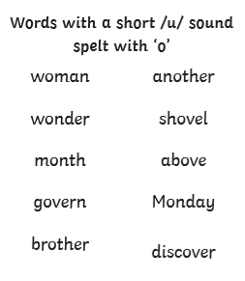  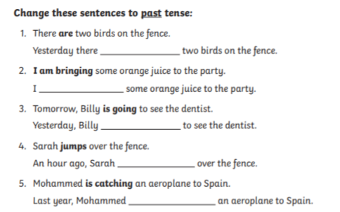  1. were  2. brought  3. went  4. jumped  5. caught
Writing  30 minutes | 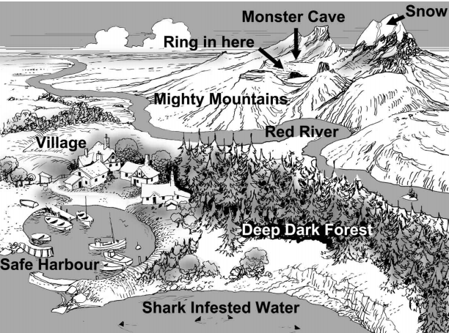  Today, I would like you to choose one of the locations on the map. I would like you to describe this location using expanded noun phrases and similes. You may want to start by drawing a picture to help you visualise what it would be like there.  E.g. The man-eating, ferocious shark’s teeth were as sharp as knives.
Arithmetic  10 minutes | Finding 100 more or less  649 + 100 = 749  234 + 100 = 334  321 + 100 = 421  765 – 100 = 665  390 – 100 = 290  125 – 100 = 25
Maths  30 minutes | 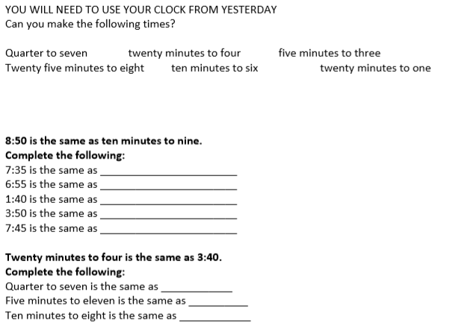  25 to 8  5 to 7  20 to 2  10 to 4  Quarter to 8  6:45  10:55  7:50
Enquiry/Project work  30 minutes | This week’s theme is rainforests! Today, I would like you to create a piece of art based on Henri Rousseau’s Jungle painting.  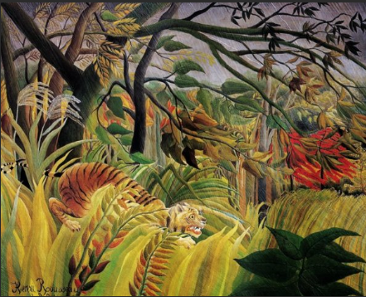  You could choose to recreate the whole painting, or a part of it. You could skecth, paint, colour, or even make a collage.

