Home Learning – 30.4.20
Thursday

Reading  30 minutes | 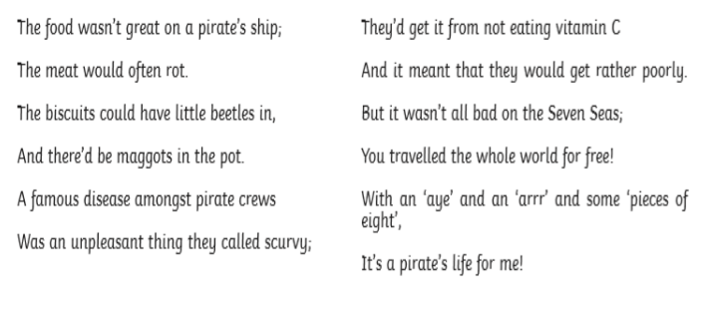  1) Why do you think that the meat would ‘often rot’? Accept answers which discuss the lack of modern refrigeration aboard pirate vessels, e.g. • The meat could have rotted because it was not kept cool, as there were no fridges on board pirate ships. • Fridges were not invented when pirates sailed so they would have had no way to keep their meat cool and fresh.  2) Why didn’t pirates eat enough vitamins? Accept any answer which discusses the fact that prolonged periods at sea gave pirates very little access to fresh fruit and vegetables, therefore creating a shortage of vitamin intake, e.g. • When pirates were out at sea they would not be able to get fruit and vegetables to give them vitamins so they would not be able to eat enough.  3) Would you have liked to have been a pirate? Explain your answer using evidence from the text. Yes because... • their lives were full of excitement and adventure. • you get to travel the world. • you could become rich from loot and bounties. • their language was fun to speak. No  because... • the food was unpleasant. • you could get poorly quite easily. • lots of pirates had unpleasant deaths. • constant sailing was very tiresome.  4) Sum up what you think are the key points of this poem. Accept any reasonable summary of the texts which includes all of the following points: • Many well-known pirates met unpleasant ends. • Food aboard pirate ships was unpleasant. • Pirates had their own language  Now for some pleasure reading! Read an e-book on Bug Club and answer the comprehension questions or choose a novel of your choice.
GPS warm-up  10 minutes | These are your 10 spellings for the week – Tip: Choose 2 words to learn each day, and then ask a grown up to test you Friday afternoon!  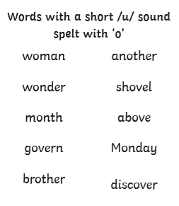  Choose don’t or doesn’t to complete these sentences –  I _________________ want to go to bed yet.  He _________________ want to go to school today.  She _______________ like bacon.  Don’t  Doesn’t  Doesn’t
Writing  30 minutes | Rewrite each sentence, choosing the correct word to make the sentence grammatically correct.  E.g. I have / has been to school today.  I have been to school today.  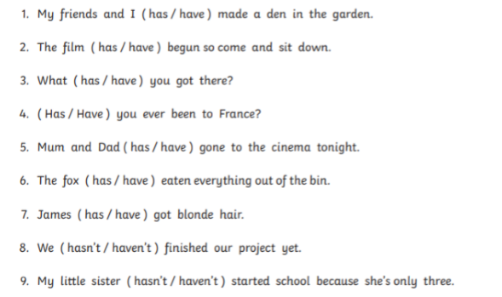  Can you write 3 of your own sentences with two words to choose between, and see if an older sibling or one of your parents can choose the right answer?
Arithmetic  10 minutes | 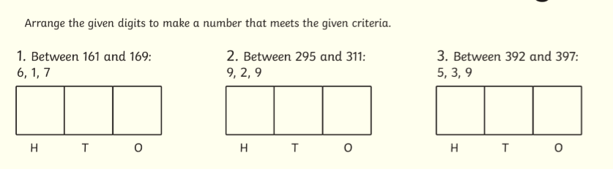  1. 167  2. 299  3. 395
Maths  30 minutes | Use your clock to help you solve the following time word problems  1) I left my house at 3.10pm and arrived at my friend’s house at 3.45pm. How long did it take me? 35 minutes  2) I started jogging at 5.15pm and returned home at 6.20pm. How long was I out jogging? 1 hour and 5 minutes  3) The bus left the station at 2.25pm and arrived at the cinema at 3.00pm. How long was the journey? 35 minutes  4) I got home at 7.25pm. My journey took me 40 minutes. What time did my journey start? 6:45pm  5) The show ended at 10.30pm. It lasted for 1 hour 25 minutes. What time did the show start? 9:05  Can you write 3 ‘time’ word problems of your own?
Enquiry/Project work  30 minutes | This week our topic is Rainforests!  I would like you to use the information you gathered to start your project.  You could create:  A 3D model  A leaflet  A PowerPoint presentation  An explanation text  A labelled diagram  Try and be as creative as you can! You could choose to do more than one thing.  