Home Learning – 27.4.20
Monday

Reading  30 minutes | Read the text ‘The Kite’  Answer the questions below.  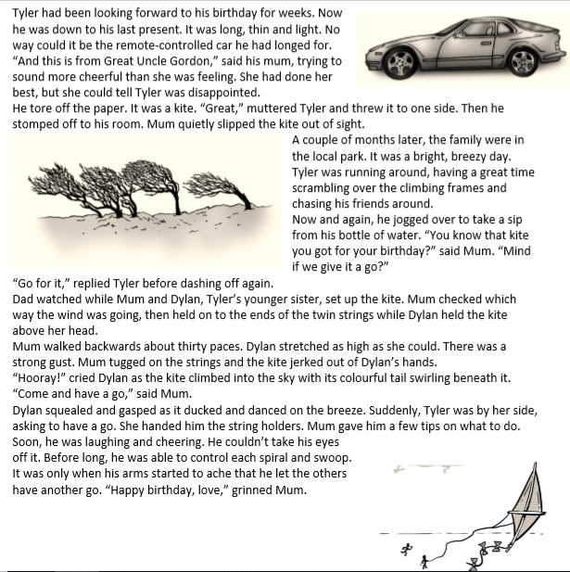  - How did Tyler feel about the kite when he was first given it?  - What does Tyler do that tells you he was disappointed?  - What was the weather like? How do you know?  - How did the kite move in the air? Which words tell you this?  - How did Tyler feel about the kite at the end of the story?  Now for some pleasure reading! Read an e-book on Bug Club and answer the comprehension questions or choose a novel of your choice.
GPS warm-up  10 minutes | These are your 10 spellings for the week – Tip: Choose 2 words to learn each day, and then ask a grown up to test you Friday afternoon!  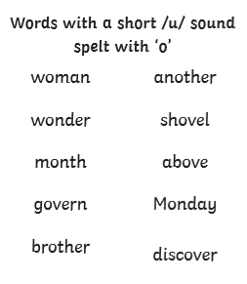  Rewrite the sentences below adding capital letters and full stops.  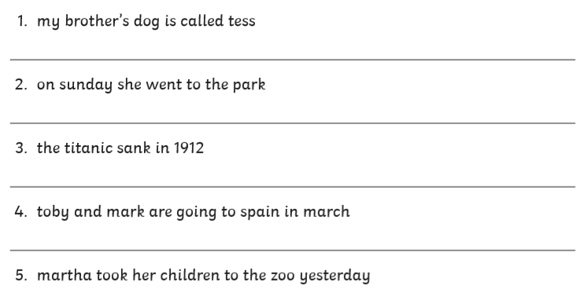
Writing  30 minutes | 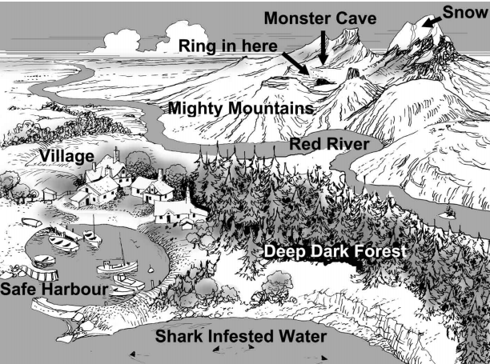  You have been given a map showing the location of a magic ring. You need to write a set of instructions to help your team find the ring. (Larger image below)  When writing your instructions remember to use:  - Numbers to show the order.  - Short, clear sentences.  - Imperative (bossy) verbs. (e.g. Walk around the edge of the harbour)  You might want to add further instructions to tell the team what to do once they have located the ring. Who do they call? How are they getting off the mountain?
Arithmetic  10 minutes | I want you to spend 10 minutes chanting your 3 and 4 times tables.  See if there is someone in your house who can play fizz buzz with you – multiples of 3 are fizz, multiples of 4 are buzz, multiples of 3 and 4 are fizz buzz.  E.g. 1, 2, fizz, buzz, 5, fizz, 7, buzz, fizz, 10, 11, fizz buzz, 13
Maths  30 minutes | Today, I would like you to tell the time confidently (past the hour). You can use the clock below to look and create your own on paper by drawing around a plate. You will also need to make two clock hands. Remember that the minute hand must be longer than the hour hand. You can use your clock for every lesson this week.  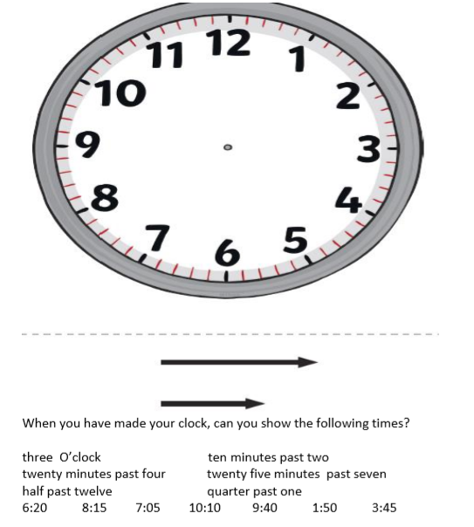
Enquiry/Project work  30 minutes | This week’s theme is Rainforests. Today, I would you like to research one animal that you would find in the rainforest.  I would like you to find out the answers to the following questions:  Where does it live? (What layer of the rainforest would you find it in?)  What does it eat?  What dangers does it face?  What is unique about the animal?

