Home Learning – 1.5.20
Friday

Reading  30 minutes | 1) If a pirate says ‘ahoy’ to you, what does it mean? hello  2) ‘...they’d plunder and pillage with glee.’ What do you think that this phrase means? Accept answers which equate the phrase to meaning happily stealing / robbing / thieving from other ships.  3) Why do you think that a pirate’s life could be tiresome? Accept answers which discuss the fact that pirates had many difficult feats, including long and arduous days sailing, boat maintenance (e.g. scrubbing the decks) and many dangerous tasks, such as fighting with other ships over loot. Example: • A pirate’s life was tiresome because they had to spend every day fighting for supplies and goods, which must have been difficult.  4) Whose body was covered in tar? Captain Kidd  5) Find and copy a phrase which the writer uses to show that many well-known pirates were not liked. ‘the best-known pirates were ‘orrible men’  6) ‘...who came to a sticky demise’ In this phrase, what do you think sticky demise means? A ‘sticky demise’ is a horrible downfall, unpleasant end or nasty death.  7) How do we know that Black Bart Roberts was not really ‘pistol-proof’? Accept any answer which infers that Black Bart Roberts could not have been as ‘pistol-proof’ as thought because, surprisingly, he was killed by a bullet, such as: • Black Bart could not have been ‘pistol-proof’ because it was a bullet from a pistol which killed him.  Now for some pleasure reading! Read an e-book on Bug Club and answer the comprehension questions or choose a novel of your choice.
GPS warm-up  10 minutes | These are your 10 spellings for the week – Tip: Choose 2 words to learn each day, and then ask a grown up to test you this afternoon!  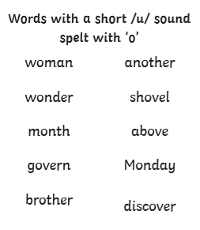  Choose of or off to complete these sentences –  I bought a pint _______ milk.  I asked the children to move ______ the field.  There are lots ______ cats in my garden.  I set ______ for France early in the morning.  Of  Off  Of  Off
Writing  30 minutes | Today I would like you to write instructions for a quest that you or a family member could follow in your house, to find some sort of object (E.g. a hairbrush in your bedroom).  Using imperative verbs, like you did on Monday, see if you can write a set of clear instructions of how to get the object. Once you have completed the instructions, test them on someone in your house.
Arithmetic  10 minutes | Finish the sequences  50, 100, 150, _200__, ___250_, 300, __350__  240, 340, 440, __540___, __640___, 740  6, 10, 14, _18___, __22__, 26
Maths  30 minutes | Use the train time table to answer the following questions.  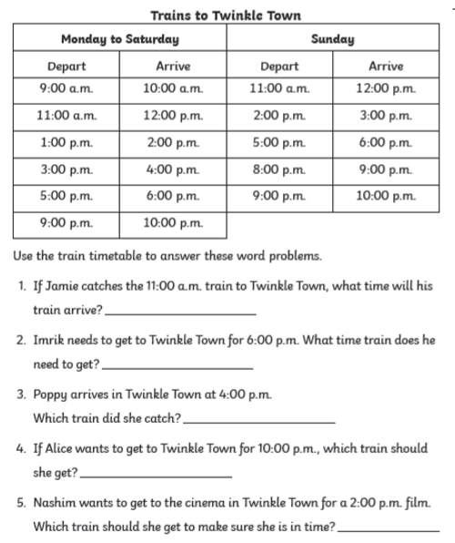  1. 12pm  2. 5pm  3. 3pm  4. 9pm  5. 11am
Enquiry/Project work  30 minutes | This week our topic is Rainforests!  Finish your projects, I would love to see them!  