Home Learning – 1.5.20
Friday

Reading  30 minutes | 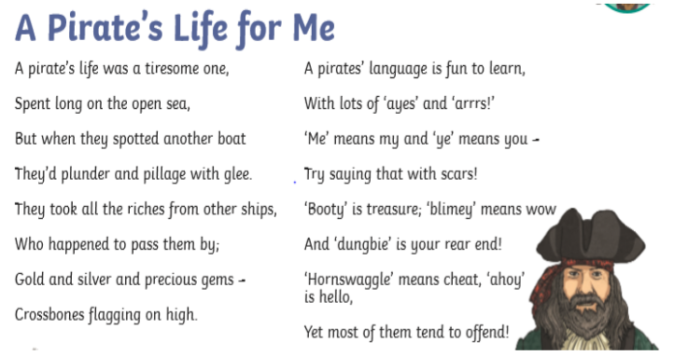  1) If a pirate says ‘ahoy’ to you, what does it mean?  2) ‘...they’d plunder and pillage with glee.’ What do you think that this phrase means?  3) Why do you think that a pirate’s life could be tiresome?  4) Whose body was covered in tar?  5) Find and copy a phrase which the writer uses to show that many well-known pirates were not liked.  6) ‘...who came to a sticky demise’ In this phrase, what do you think sticky demise means?  7) How do we know that Black Bart Roberts was not really ‘pistol-proof’?  Now for some pleasure reading! Read an e-book on Bug Club and answer the comprehension questions or choose a novel of your choice.
GPS warm-up  10 minutes | These are your 10 spellings for the week – Tip: Choose 2 words to learn each day, and then ask a grown up to test you this afternoon!  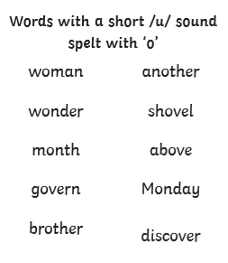  Choose of or off to complete these sentences –  I bought a pint _______ milk.  I asked the children to move ______ the field.  There are lots ______ cats in my garden.  I set ______ for France early in the morning.
Writing  30 minutes | Today I would like you to write instructions for a quest that you or a family member could follow in your house, to find some sort of object (E.g. a hairbrush in your bedroom).  Using imperative verbs, like you did on Monday, see if you can write a set of clear instructions of how to get the object. Once you have completed the instructions, test them on someone in your house.
Arithmetic  10 minutes | Finish the sequences  50, 100, 150, ___, ____, 300, ____  240, 340, 440, _____, _____, 740  6, 10, 14, ____, ____, 26
Maths  30 minutes | Use the train time table to answer the following questions.  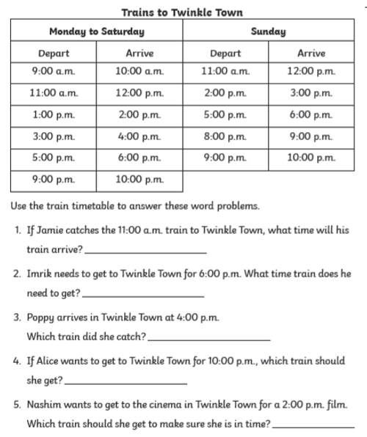
Enquiry/Project work  30 minutes | This week our topic is Rainforests!  Finish your projects, I would love to see them!  