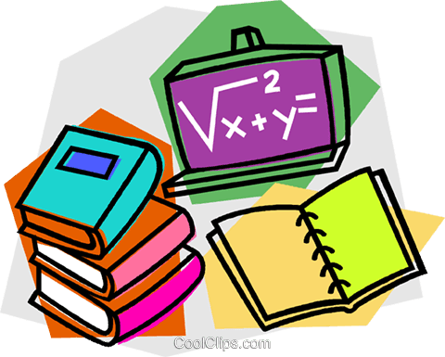
Answers – 30.04.20

Reading  30 minutes | Vocabulary:  1. particularly  2. pity / empathy / concern (or similar)  3. sleepy / slow-moving (or similar)  Retrieval:  4. to get her homework (task)  5. Ms Eastwood  6. lightly squeezed her shoulder  Inference:  7. She wanted to make sure her friends didn’t see her (going back into school).  8. She felt a little annoyed or frustrated because she tutted when she saw Ms Eastwood.  9. She had run out of charge/electricity. She seemed to start regaining her energy when she put her hand into the glowing box. Then, Mrs Cruz plugged a charging lead into her foot, flicked a switch and she started to glow, like an appliance recharging.  Summarise:  10.  2 Ms Eastwood comes around the corner.  4 Mrs Cruz drives out of the school.  1 Lily goes into Mr Khan’s room.  3 The teachers began to glow.  Predict:  11. Accept answers that draw on the text, such as unplugging the staff or switching the staff back on so that they can get ready to teach again.  Compare:  12. At the beginning, Lily is a little frustrated that she has to go back into school but worried about what might happen if she doesn’t do her homework and anxious not to be seen by any of her school friends. At the end she is amazed by what she has seen because the text says that her head was still swirling.
GPS warm-up  10 minutes | 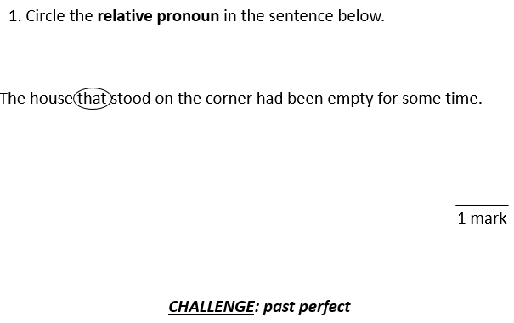  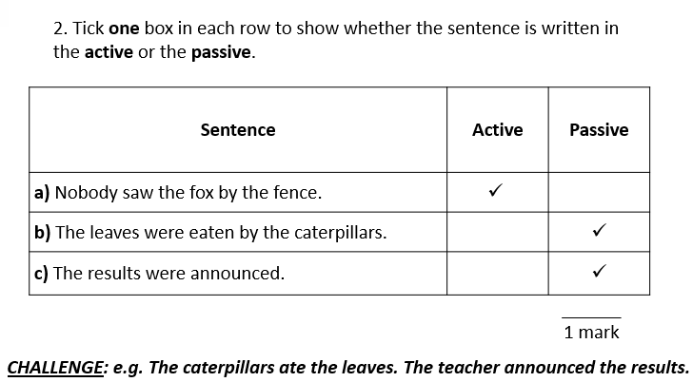  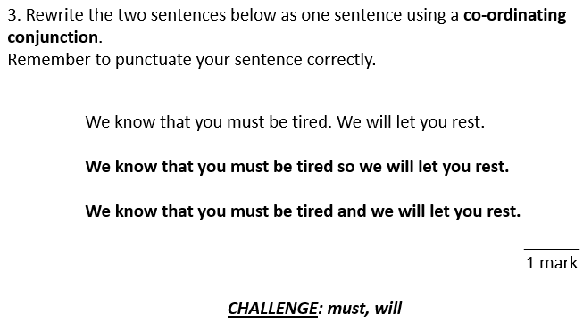
Writing  30 minutes | Editing for meaning Task 1 ANSWERS  1. Read the extract from this set of instructions below.  How to build a model Viking ship  1. Construct the long and narrow hull of boat using lollipop sticks and hot glue. Make the bow (forward part of the hull) tall enough so that water does wash over the top of the bow. Ensure that the size and shape of the bow and the stern matched (so the ship can be used efficiently in either direction).  2. Build a keel for the underside of the hull. This ran down the middle of the bottom of the ship from bow to stern, to provide ballast to stabilise the boat and stick the keel onto the hull.  3. After creating the hull and keel, makes a single mast and sail for the ship. Attach a single mast and sail to the hull using glue.  3. Complete the grid below.  Below are suggestions as to how amendments could be made.  List any omissions. hull of boat – hull of the boat so that water does wash over the top of it – so that water does not wash over the top of it  List any repetitions (check where pronouns could be included). over the top of the bow – over the top of it Attach a single mast and sail to the hull using glue. – Attach it to the hull using glue.  List any over-long, over-short or unclear sentences. This runs down the middle of the bottom of the ship, from bow to stern, to provide ballast to stabilise the boat and stick the keel onto the hull. This runs down the middle of the bottom of the ship, from bow to stern, to provide ballast to stabilise the boat. Stick the keel onto the hull.  List any missing or inaccurate punctuation. of the bottom of the ship from bow to stern, of the bottom of the ship, from bow to stern,  List any inconsistent use of tense or perspective (person). matched – match This ran down the middle of the – This runs down the middle of the  List any grammatically incorrect English. makes a single mast – make a single mast  4. Rewrite the extract, making the amendments which you have identified in the grid above.  Suggestion:  How to build a model Viking ship  1. Construct the long and narrow hull of the boat using lollipop sticks and hot glue. Make the bow (forward part of the hull) tall enough so that water does not wash over the top of it. Ensure that the size and shape of the bow and the stern match (so the ship can be used efficiently in either direction).  2. Build a keel for the underside of the hull. This runs down the middle of the bottom of the ship, from bow to stern, to provide ballast to stabilise the boat. Stick the keel onto the hull.  3. After creating the hull and keel, make a single mast and sail for the ship. Attach it to the hull using glue.
Arithmetic  10 minutes | 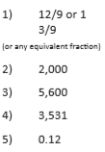
Maths  30 minutes | Answers  1)  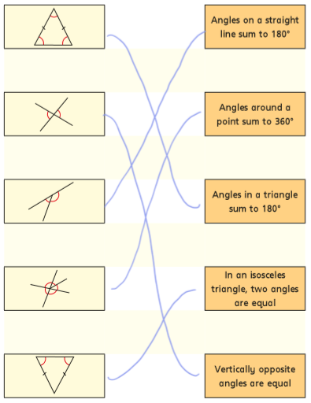  2a) a= 71° because vertically opposite angles are equal/ the same.  b= 46° because all the angles in a triangle add up 180°.  2b) d= 43° because angles on a straight line add up to 180°.  e= 43° because in an isosceles triangle two angles are the same.  f= 94° because angles in a triangle add up to 180°.  2c) g= 51° because angles around a pint add up to 360°.  h= 90° because angles on a straight line add up 180°.  i= 39° because angles in a triangle add up to 180°.  3a)  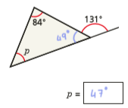  3b)  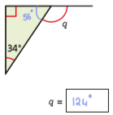  3c)  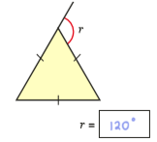  3d)  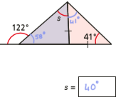  3e)  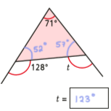  3f)  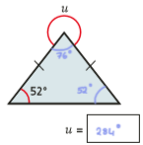  3g)  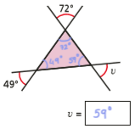  3h)  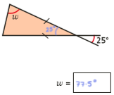  4)  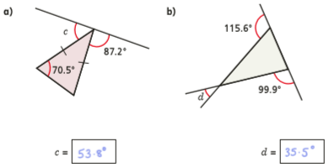  5) 180-37=143°  143 halved= 71.5°  71.5-48=23.5°  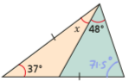  x=23.5°  6)  Option1:  61+61=122  180-122=58  y= 180-58=122°  Option2:  180-61=119  119 halved= 59.5  y= 180-59.5=120.5°
Enquiry/Project work  30 minutes | This is optional, but if you would like to show off your boating creation I would love to see them and hear whether or not your boat survived the savage seas (bucket or bowl of water). Take a picture and email them to the year 6 support address.

