Answers – 28.04.20

Reading  30 minutes | Vocabulary:  1. live on the edge of a large town/city  2. comfort  3. always fair/doesn’t treat them unfairly  Retrieval:  4. as a means of getting to places - e.g. Maskelyne and Cook's, the Pantomime, Zoological Gardens, and Madame Tussaud's  5. he always had an excellent reason for it/explained the reason to the children so interestingly and funnily (that they felt sure he couldn't help himself)  6. the Engine suddenly went off with a bang/his engine broke  Inference:  7. the dreadful change came quite suddenly/they did not know HOW happy till the pretty life in the Red Villa was over and done with, and they had to live a very different life indeed  8. Accept any two from:  She was almost always there/ ready to play with the children/read to them/helped them to do their home-lessons/wrote stories for them/ made up funny pieces of poetry for their birthdays and for other great occasions  9. He gets his appetite back/he wants to have something REAL to eat (also accept: he suddenly sat up in bed)  Summarise:  10.  1  The children are only aware of the railways as a way of getting around.  4  They children had everything they needed at home.  5  Peter is affected by the loss of his new engine.  3  Their mother writes things for them for different reasons.  2  The three children were called Roberta, Peter and Phyllis.  Compare:  11. She isn’t dull/doesn’t sit at home waiting around for dull ladies to pay calls to her/doesn’t spend all her time in paying dull calls to dull ladies
GPS warm-up  10 minutes | 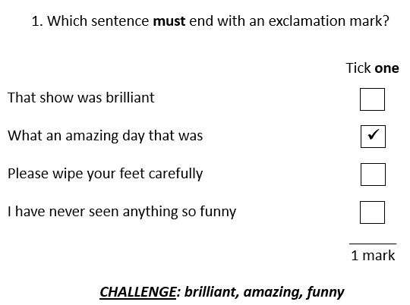  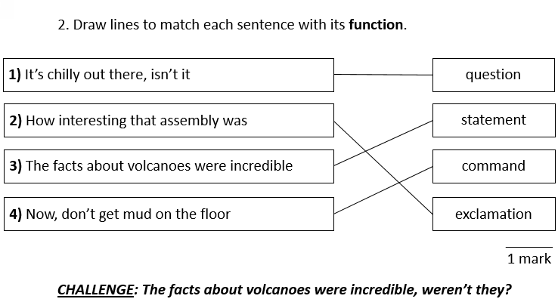  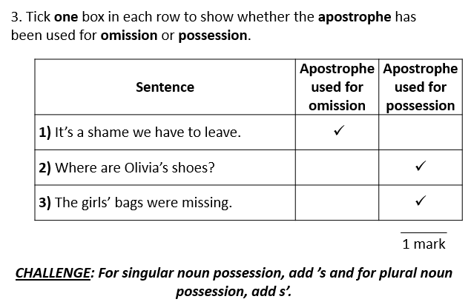
Writing  30 minutes | Editing as you go Task 2 ANSWERS  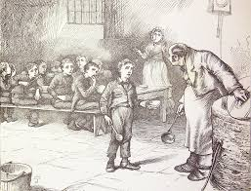 25th March 1874.  Dear Diary,  I didn’t think life could get any harder in this place but I were wrong. Desparate to see my mother (who I haven’t caught a glimse of when we arrived at the workhouse) I snuck out of the dormitory last night to try and found her. The matron caught me as she as doing her rounds and I am now forbidden to have any food for two days. It has come to my attention, that I never thought I’d miss the gruel they slop on our plates each and every day but as I crouch hear in the darkness my stomach growls for even a morsel of the sludge — disgusting as is.  3. Complete the grid below.  Below are suggestions as to how amendments could be made.  List the sections of the text which do not make sense. disgusting as is – disgusting as it is as she as doing her – as she was doing her  List the grammatical errors. to try and found her – to try and find her but I were wrong – but I was wrong  List the spelling errors. desparate – desperate glimse – glimpse hear – here  Write a sentence which could be improved. (who I haven’t caught a glimse of when we arrived at the workhouse) – (who I haven’t caught a glimpse of since we arrived at the workhouse)  Write a feature of the genre of writing which could be added to the extract. ‘It has come to my attention,’ – replace this with a sentence opener more appropriate and informal for a diary entry.  4. Rewrite the extract, making the amendments which you have identified in the grid above.  Suggestion:  25th March 1874  Dear Diary,  I didn’t think life could get any harder in this place but I was wrong. Desperate to see my mother (who I haven’t caught a glimpse of since we arrived at the workhouse) I snuck out of the dormitory last night to try and find her. The matron caught me as she was doing her rounds and I am now forbidden to have any food for two days. Certainly, I never thought I’d miss the gruel they slop onto our plates each and every day but as I crouch here in the darkness my stomach growls for even a morsel of the sludge — disgusting as it is.
Arithmetic  10 minutes | 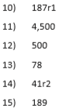
Maths  30 minutes | 1a) 180°  Adjacent angles on a straight line have a sum of 108°.  b) rough estimation near to these examples:  a=40° b=80° c=60°  c) 180°  d) Angles in a triangle add up to 180°.  2a) 41° because angles in a triangle add up to 180°.  b) 97° because angles in a triangle add up to 180°.  c) 55° because angles in a triangle add up to 180°.  d) 121° because angles in a triangle add up to 180°.  3a) 68.4°  b) 36.3°  c) 139°  d) 60.7°  4a) 81°  b) 156°  c) 66°  5)  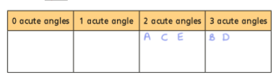  The angles of a triangle add up to 180° so there has to be at least 2 acute angles.  6) No  He hasn’t included the right angle. P=53 °
Enquiry/Project work  30 minutes | No answers required.

