Answers – 01.05.20

Reading  30 minutes | Set B:  Vocabulary:  1. disastrous  2. exhausted / tired out / lacking energy  3. someone who works with you / co-worker  Retrieval:  4. Mr Khan  5. behind a storage cupboard  6. (about) five minutes  Inference:  7. She would have been in trouble, both with the school and her parents. The text says that if her folks got another call from her teacher about her homework, it would be disastrous. Therefore, we can guess that this had happened before and they would not be pleased if it happened again.  8. She saw the office was closed / she didn’t want to wait until a teacher saw her waiting to get in / she spotted that Mr Khan had left his door open.  9. The teachers were robots/androids (or similar). We know this because they ran out of energy at the end of the day and had to be plugged in to recharge overnight.  Meaning as a whole:  10.  … the container was pulsing with pale blue light …  Past events  Before Lily could decide what to do next …  Setting  It would only occur to her later that she should have just gone to the front door and asked ...  Dilemma  … if her folks got another call from her teacher ...  Character  Authorial intent:  11. The author was playing on the different meanings of the phrase recharge your batteries. In most cases, it just means that someone has to rest and regain some of their natural energy but here, because the teachers are powered by electricity, they literally needed to recharge their batteries at the end of the day.  Compare:  12. At the beginning, Lily is probably a little scared of teachers because she doesn’t want them to call her parents, nor does she want them to see her in school. However, when she sees Ms Eastwood grind to a halt, she feels unexpected sympathy, which means she feels sorry for them, probably because Ms Eastwood looks so tired. Alternatively, accept answers that suggest she feels sympathy for them, but this turns to amazement, confusion or even fear when she realises that the teachers in her school are actually robots.
GPS warm-up  10 minutes | 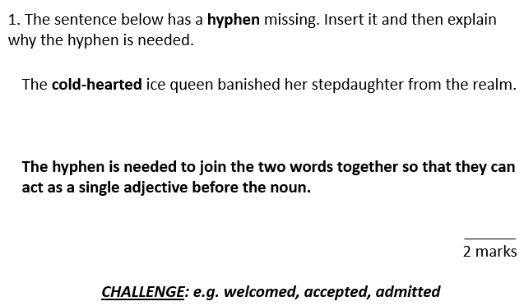  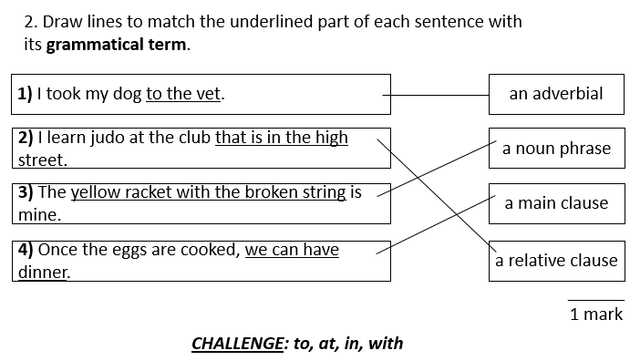  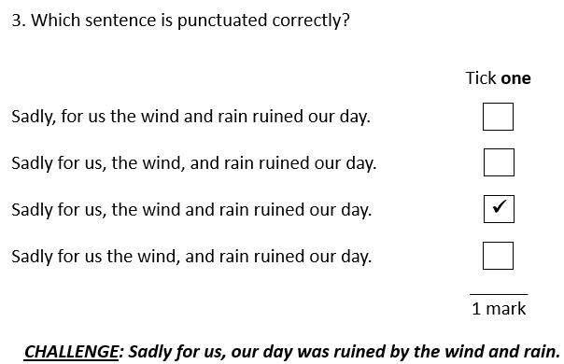
Writing  30 minutes | Editing for meaning Task 2 ANSWERS  There once was a great warrior. He was Prince Rama, who has a beautiful wife named Princess Sita. Banished from their home by the king, Rama and Sita was joined by Rama’s brother (Lakshmana in) exile.  A terrible demon king, Ravana, who had ten heads and twenty arms, kidnapped Sita and fled with her in Ravana’s chariot. Sita, known for her ingenuity, sprinkles a trail of her jewellery for Rama to follow. Not long after Rama and Lakshmana discovered the trail and followed the path gleaming jewels until they met the monkey king, Hanuman. He become their friend and agreed to help find Sita by sending messages to all the monkeys in world, urging them to find Sita.  3. Complete the grid below.  Below are suggestions as to how amendments could be made.  List any omissions. followed the path gleaming jewels – followed the path of gleaming jewels in world – in the world  List any repetitions (check where pronouns could be included). and fled with her in Ravana’s chariot. – and fled with her in his chariot. in the world, urging them to find Sita. – in the world, urging them to find her/the princess/the abducted princess.  List any over-long, over-short or unclear sentences. There once was a great warrior. He was Prince Rama, who had a beautiful wife named Princess Sita. – There once was a great warrior, Prince Rama, who had a beautiful wife named Princess Sita.  List any missing or inaccurate punctuation. were joined by Rama’s brother (Lakshmana in) exile. – were joined by Rama’s brother (Lakshmana) in exile. Not long after Rama and Lakshmana – Not long after, Rama and Lakshmana  List any inconsistent use of tense or perspective (person). who has a beautiful wife named – who had a beautiful wife named for her ingenuity, sprinkles a trail of her jewellery – for her ingenuity, sprinkled a trail of her jewellery  List any grammatically incorrect English. Rama and Sita was joined by – Rama and Sita were joined by He become their friend – He became their friend  4. Rewrite the extract, making the amendments which you have identified in the grid above.  Suggestion  There once was a great warrior, Prince Rama, who had a beautiful wife named Princess Sita. Banished from their home by the king, Rama and Sita were joined by Rama’s brother (Lakshmana) in exile.  A terrible demon king, Ravana, who had ten heads and twenty arms, kidnapped Sita and fled with her in his chariot. Sita, known for her ingenuity, sprinkled a trail of her jewellery for Rama to follow. Not long after, Rama and Lakshmana discovered the trail and followed the path of gleaming jewels until they met the monkey king, Hanuman. He became their friend and agreed to help find Sita by sending messages to all the monkeys in the world, urging them to find the abducted princess.
Arithmetic  10 minutes | 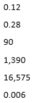
Maths  30 minutes | Calculate angles.  1a) Answers can be any two numbers which add up to 180°. However, angle a must be a bigger angle than b. For example a=130° b=50°.  1b) 180°  1c) add up to 180°  2a)  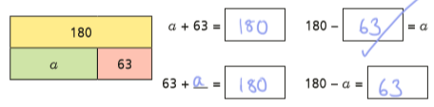  2b) 180-63=a  2c) a=117  2d) because all angles on a straight line must add up to 180°.  3a) e=122°  3b) g=39°  3c) x=131°  3d) a=48°  3e) y=118°  3f) z=100°  4a)  4b) 360°  4c) angles around a point add up to 360°.  5a) c=150°  5b) x=105°  5c) a=118°  5d) z=160°  6) No  The angles are not next to each other. There is not enough information to work out the size of angle b.  7a) a=120° b= 240°  7b) a= 72° b=18°  8)  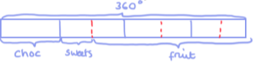  Chocolate= 90° Sweets= 45° Fruit=225°
Enquiry/Project work  30 minutes | No answers necessary.

