Home Learning – 01.05.20

Reading  30 minutes | The Secret of the Staff Room  What would her friends say if they saw her? With a quick look over her shoulder, Lily ducked under the barrier. It wasn’t that she particularly wanted to go back into school but if her folks got another call from her teacher about her homework, it would be disastrous. So, having left it behind again, she just had to go back and get it. Yes, all the children would have left by now, but teachers never went home – everybody knew that.  It would only occur to her later that she should have just gone to the front door and asked – no one would have minded. Besides, she could see that the office was closed. It could take ages for one of the teachers to stop whatever it was they did after school and notice her waiting. So, when she spotted that Mr Khan had left the back door of his classroom open, she grasped the opportunity without really thinking.  This was beginning to feel like an adventure. Her next challenge was to sneak past the staff room door unnoticed. She was just about to try when Ms Eastwood came around the corner. Ducking behind a storage cupboard, Lily felt a surge of unexpected sympathy, seeing how completely drained the teacher looked. She wasn’t ready for what happened next, however. Ms Eastwood simply ground to a halt, a few steps from the staff room door.  Before Lily could decide what to do next, Mrs Cruz, the head teacher, appeared. Tutting quietly, she lightly squeezed Ms Eastwood’s shoulder and her eyes immediately reopened. “Looks like you need to recharge your batteries,” smiled Mrs Cruz and she guided her still sluggish colleague through the door.  Seizing her moment, Lily crept along the corridor. The staffroom door was still open and an extraordinary sight met her eyes. Mrs Cruz was sitting beside Ms Eastwood, guiding her outstretched hand into a brightly coloured, octagonal container of Treat Selection chocolates – nothing particularly unusual about that except that the container was pulsing with pale blue light and the teacher was clearly regaining her energy.  By the time Lily had reached her classroom, retrieved the homework and made her way back, there was a queue of teachers waiting silently outside the staffroom. She had to wait about five minutes before they had all shuffled in and closed the door so that she could get past and get out again.  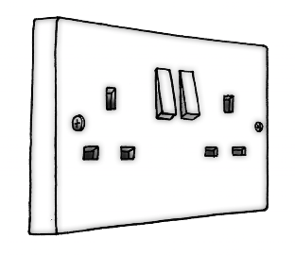  As she made her way back around the outside of the school, she couldn’t resist having a peak in at the staff room window. By the faint light of the chocolate box, she could see that all the teachers were sitting stock-still in rows with one shoe off and Mrs Cruz was crawling around the floor. Straining her eyes, Lily could just make out that she was plugging charging leads into a socket in the soles of their feet. When the last one was done, she picked up her coat and bag, flicked a switch on the wall and left. All the seated teachers remained still but began to glow gently.  With her head still swirling, Lily just about managed to duck back under the car park barrier and around the corner when she heard Mrs Cruz’s car coming. She turned out of the school drive and the barrier closed behind her, leaving her “staff” to revive overnight.  Vocabulary:  1. Look at the first paragraph. Find and copy a word that means terrible.  _________________________________________________________________  2. Look at the third paragraph.  … seeing how completely drained the teacher looked … What does drained mean in this sentence?  _________________________________________________________________  3. … she guided her still sluggish colleague through the door … What does the word colleague mean in this sentence?  _________________________________________________________________  Retrieval:  4. Who had left a door open? Circle one.  Mr Khan Mrs Cruz Lily Ms Eastwood  5. Where did Lily hide when Ms Eastwood appeared?  _________________________________________________________________  6. How long did Lily have to wait before all the teachers had gone into the staff room?  _________________________________________________________________  Inference:  7. What do you think would have happened if Lily had not done her homework that night? Use evidence from the text to explain your answer.  ______________________________________________________________________  ______________________________________________________________________  8. Why didn’t Lily just go in through the front door?  ______________________________________________________________________  9. What were the teachers? Use evidence from the text to support your answer.  _____________________________________________________________________  _____________________________________________________________________  Meaning as a whole:  10. Draw lines to match each part of the story with the correct quotation from the text.  Past events  … the container was pulsing with pale blue light …  Before Lily could decide what to do next …  Setting  Dilemma  It would only occur to her later that she should have just gone to the front door and asked ...  Character  … if her folks got another call from her teacher ...  Authorial intent:  11. “Looks like you need to recharge your batteries,” smiled Mrs Cruz ... Why did the author use this choice of words?  ______________________________________________________________________  ______________________________________________________________________  ______________________________________________________________________  Compare:  12. Lily’s opinion of teachers changes throughout the text. Describe one change.  ___________________________________________________________________  ___________________________________________________________________  ___________________________________________________________________  ___________________________________________________________________
GPS warm-up  10 minutes | The challenge activities provide opportunities for children to practise some of the more difficult objectives and question types. Where questions require a written answer, children should be reminded to take particular care with spelling and punctuation (e.g. use of capital letters and full stops). Children can write answers in an exercise books.  If you are unsure what the question is asking, use your homework book to find out what is means. For example if you need to know what a subordinate conjunction is, turn to that page of your book and it should explain.  HELPFUL HINT: the sign -, used to join words to indicate that they have a combined meaning or that they are linked in the grammar of a sentence (as in a pick-me-up, rock-forming minerals).  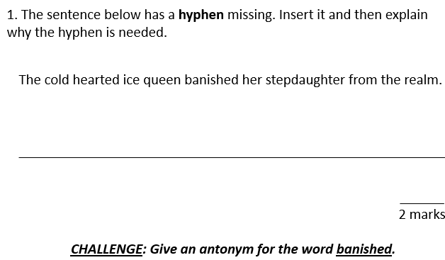  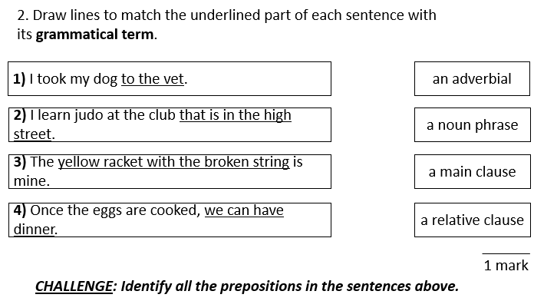  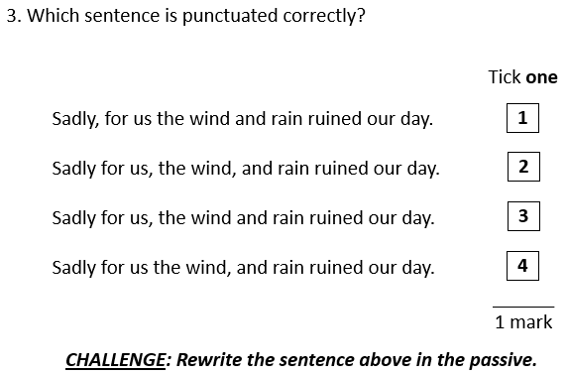
Writing  30 minutes | Editing for meaning Task 2  Read the extract from this narrative text below  There once was a great warrior. He was Prince Rama, who has a beautiful wife named Princess Sita. Banished from their home by the king, Rama and Sita was joined by Rama’s brother (Lakshmana in) exile. A terrible demon king, Ravana, who had ten heads and twenty arms, kidnapped Sita and fled with in Ravana’s chariot. Sita, known for her ingenuity, sprinkles a trail of her jewellery for Rama to follow. Not long after Rama and Lakshmana discovered the trail and followed the path gleaming jewels until they met the monkey king, Hanuman. He become their friend and agreed to help find Sita by sending messages to all the monkeys in world, urging them to find Sita.  2. After reading the extract, check for the following aspects and underline them:  - omissions  - repetitions (check where pronouns could be included)  - over-long, over-short or unclear sentences  - missing or inaccurate punctuation  - inconsistent use of tense or perspective (person)  - grammatically incorrect English  3. Complete the grid below.  List any omissions.  List any repetitions (check where pronouns could be included).  List any over-long, over-short or unclear sentences.  List any missing or inaccurate punctuation.  List any inconsistent use of tense or perspective (person).  List any grammatically incorrect English.  4. Rewrite the extract, making the amendments which you have identified in the grid above.  ___________________________________________________________________________________________________________________________________________________________________________________________________________________________________________________________________________________________________________________________________________________________________________________________________________________________________________________________________________________________________________________________________________________________________________________________________________________________________________________________________________________________________________________________________________________________________________________________________________________________________________________________________________________________________________________________________________________________________________________________________________________________________________________________________________________________________________________________________________________________________________________________________________________________________________________________________________________________________________________________
Arithmetic  10 minutes | 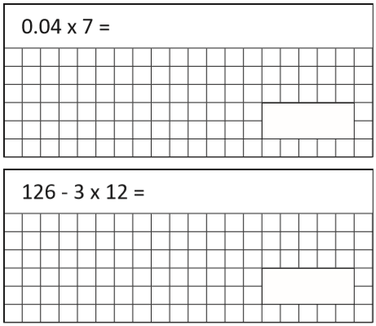  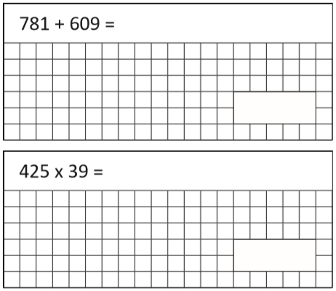  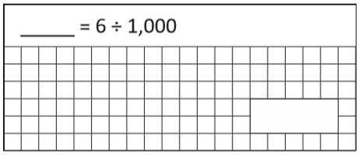
Maths  30 minutes | Calculate angles.  Monday’s maths challenge will help you with the learning today  - Two angles, a and b, are adjacent on a straight line.  - Estimate the size of angle a and b.  a=____ b=____  - What is the total of the two angles? _____  - Complete the sentence.  Adjacent angles on a straight line _____________________________.  - Complete the fact family for the bar model  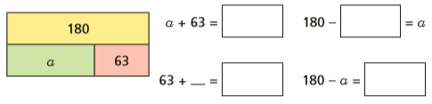  - Tick the calculation in part a) that helps you work out the value of a.  - Work out the value of a. a= _____  - How does the bar model help you to calculate angle a?  - Work out the unknown angles.  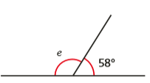 e=_____  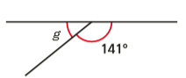 g=_____  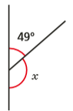 x=_____  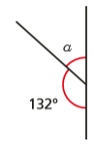 a= _____  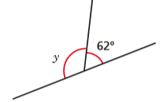 y=_____  f)  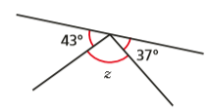z=_____  - Dora is facing in the direction shown by the arrow. She does a full turn clockwise.  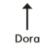  - Show Dora’s turn on the diagram.  - How many degrees did Dora turn through? ________  - Use your answer to part b) to help you complete the sentence.  Angles around a point _____________________________________________.  - Work out the unknown angles  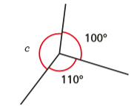 c=_____  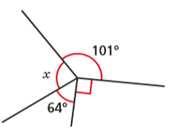 x=_____  - 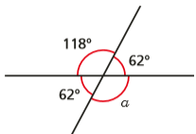 a=_____  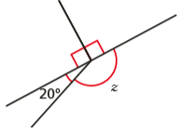 z=______  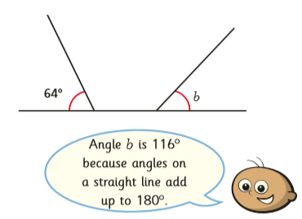  Do you agree with Tommy? Yes/No  Explain your answer  ______________________________________________________________________________________________________________________________________________________________________________________________________________________________  - Use the information to work out the unknown angles.  - Angle a is half the size of angle b  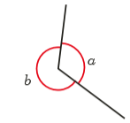 a=_____ b=_____  - Angle a is four times the size of angle b.  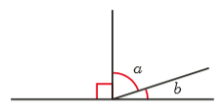 a=_____ b=_____  - The pie chart shows some children’s favourite snacks.  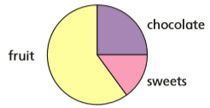  A quarter of the children said chocolate was their favourite snack. Five times as many children voted for fruit as voted for sweets. Work out the size of the angle for each sector in the pie chart.  Chocolate=________ sweets=_________ Fruit=________
Enquiry/Project work  30 minutes | Computing  Spend half an hour on read theory. How many knowledge points will you earn? Remember you do not need a laptop, you can use a mobile phone if you have one. You now have bug club which you could also have a go at.  Alternatively, you could work on your times table skills and spend some time on Timetable Rock Stars. Your class friends might be playing at the same time as you so why not challenge them.  Hit the button is also another option. I know some of your prefer this game. Challenge the adults in your home. Who can score the most? https://www.topmarks.co.uk/maths-games/hit-the-button  If you do not have access to a computer, tablet or phone then you could pick up a book and read for 30 minutes or even write your own short story for someone in your house to read.  If you’d rather not read, you could recite your timetables. Make up a rap? Make up a dance? Make your own timetable chart? Teach a table to a younger sibling? Have some fun remembering those important time tables!

