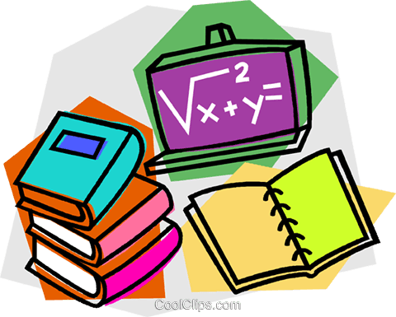
Year 2 Home Learning
28/04/20
Suggested daily timetable
9am – Morning meditation
9:05 – 9:35- Reading comprehension
9:45 – 10:00 Grammar and punctuation
10:00 – 10:30 – Writing
10:30 – 11:00 – Break and exercise
11:00 – 11:15 – Spelling/handwriting
11:15 – 11:45 - Maths
11:45 – 12:00 – Story time
12:00 – 1:30 – Lunch break.
1:30 – 2:00 – Bug club reading
2:00 – 2:30 – PE (use Joe Wick on YouTube if you aren’t already!)
2:30 – 3:15 – Curriculum.
3:15 – 3:20 - Music

Here is your Home Learning Timetable for today and an example of a daily timetable you may wish to follow. I have altered it slightly from last week to fit in time for Bug Club after lunch. There is also some music at the end of the day. This document will give you hints and tips on how to deliver the material and exactly what they should be doing. The weekly slides are ‘child friendly’ and will guide them through the day in more simple language. I have made everything more accessible for those people who cannot get online for any reason by providing alternative suggestions for activities
Feel free to change or personalise the material. Explain anything they don’t understand in your own words and remind them it’s OK to get stuff wrong; that’s when we learn!
Please do as much or as little as you can. This is such an unusual and stressful time for many so our priority should always be the well-being of ourselves and the ones we care about.
This week’s theme is ‘animals’.
Relaxation  5 minutes | Click on the link on the slide or type this in.  https://www.youtube.com/watch?v=1unEqeYwe0Q  Remember: This is important for our learning. With a clear mind we can concentrate more easily!  Tip for parents – If your child feels silly doing this or doesn’t want to, join in with them!  Tip for parents – If you don’t have access to a device or the internet, sit with your child somewhere comfortable and tell them to close their eyes and take five deep breaths through their nose and out through their mouths. Ask them to focus on the little noises they can hear outside, and around your house. Tell them it’s OK if their mind wanders, just bring their thoughts round to their breathing and what they can hear.
Reading comp  30 minutes | Have your child look carefully at the text. Get them to read each part to you or read it with them then answer the questions about it.  Meet the Crocodile  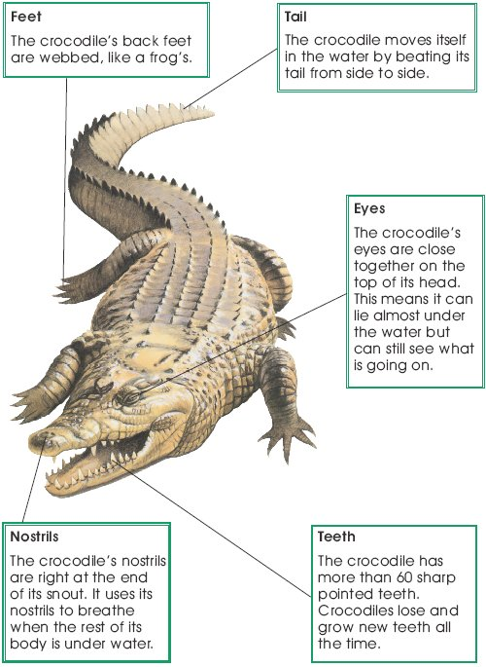  1 When a crocodile is lying under the water, which parts of its  body can you see?  Tick two.  feet eyes  teeth tail  nostrils  2 Why does the crocodile beat its tail from side to side?  ______________________________________________________________  3 Why does the crocodile have eyes on top of its head?  ______________________________________________________________  4 Which part of the crocodile is like a frog?  Tick one.  Teeth Eyes  Nostrils Feet
Grammar and punctuation  10 minutes | Copy these sentences:  The goat bleats loudly.  Why did the goat make that noise?  Go away, goat.  What a noisy goat that was!  Write if these sentences are in past or present tense.  Challenge: How do you know?  Tip: The verb in a sentence shows the tense.
Writing  30 minutes | Story planning:  Ask your child to look at this picture then write at least one full sentence for each section. (Template at the bottom).  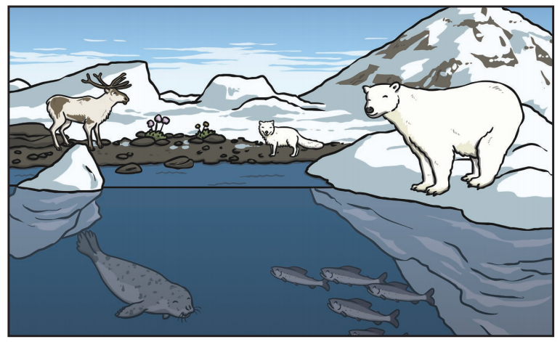  Who is the main character in this story?  Where is the story set?  What problem did the main character have?  How was the problem solved?  How might the story end?  In year 2, when we write, we always include:  - Capital letters and full stops.  - Neat handwriting.  - Great spelling (it’s OK to ask an adult!)  - Conjunctions (only one for each sentence).  Tip – If your child’s sentences don’t make sense, encourage them to read them back out loud. In our class we: ‘Think it, say it, write it, read it’. So they think of their sentence, say their sentence out loud, write their sentence, and then read it back out loud.
Spelling and Handwriting  15 minutes | We are going to practice some common exception words that the children are expected to be able to spell by the end of year 2. Common exception words are words that ‘break the rules’ and cannot be sounded out phonetically. We will be doing 10 in total this week with a test on Friday.  Have your child either copy these words 5 times or they could use the ‘look, cover, copy’ method if they are really confident with their handwriting:  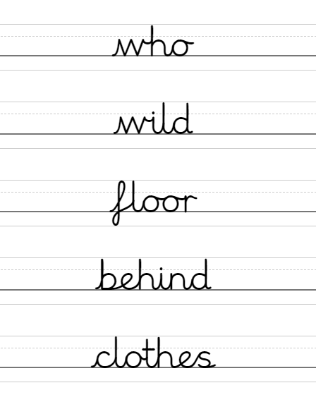  Challenge: Can you use each one in a sentence?
Maths  30 minutes | (Tip for parents) – This is recapping how to add two 2-digit numbers together without ‘bridging ten’ (where two of the digits add up to more than 10). The method we use is simple, add the tens together then add the ones together. Feel free to show them other ways of doing it if you like.  Mrs Wilkins owns a very unusual pet shop!  But she only lets you buy two animals… Which ones do like best? How much would they cost together? Can you write an equation for you purchase?  - Which pair of animals would cost the most?  - Which pair would cost the least?  - Are there any two pairs that would cost the same?  Try as many combinations as you can think of!  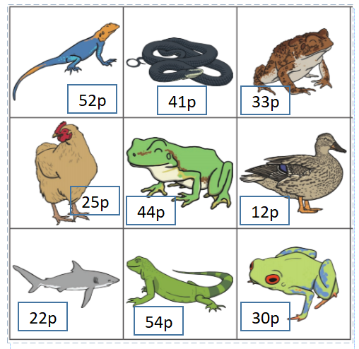  Challenge: Write the equation families for each one.  52 + 41 = 93, so:  41 + 52 =93  93 – 52 = 41  93 – 41 = 52
Youtube story | Quackenstein Hatches a Family read by Kristen Bell  https://www.youtube.com/watch?v=xoiS5ZFtqVg  (Or read your own book to them instead!)
Reading | Log onto ‘Bugclub’ and have the children read one of their stories. Then answer the questions about it.  - If you do not have your login let me know and I will send it to you.  - If you do not have a suitable device, choose a book that your child can read confidently and get them to read it to you. Ask them questions like “What was the story about?” “What did you think of the story? Why?” “What might happen after this?” “What was your favourite part?” “Does it remind you of any other stories?  Tip – Get them to read the story twice, out loud. The first time they can concentrate on the sounds and new words. Make sure that the second time they read the story, they read it as they would ‘say’ it (using a conversational tone).
PE with Joe Wicks  30 minutes | https://www.youtube.com/user/thebodycoach1  Find today’s episode and clear a space so your child can really get into it.  Join in with them if they’re feeling self-conscious!  If you can’t access this then get your child to do some exercise that will raise their heart-rate and get them out of breath. Set them a challenge, race them down the street, do a dance, do some aerobics… anything you can think of!
Curriculum  45 minutes | Ask your child this question:  If an animal is a ‘herbivore’, what does it eat? (plants).  Can you think of what animals that only eat meat are called? (carnivore)  What about animals that meat and plants? (omnivore)  Look at how these words are made:  Today, we are going to make a Venn diagram. Here’s an example:  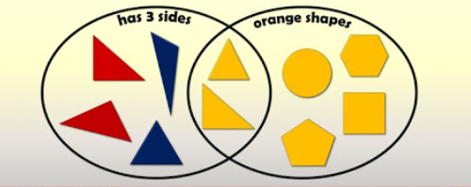  You might have to find a very big bit of paper to give you space. Or you could stick some together!  In the left hand bubble will be the carnivores. Write down or draw as many as you can think of.  In the right hand bubble will be the herbivores. Remember, only put animals in this bubble that eat meat.  In the space where the two bubbles overlap will be the omnivores. That’s because they eat meat and plants!  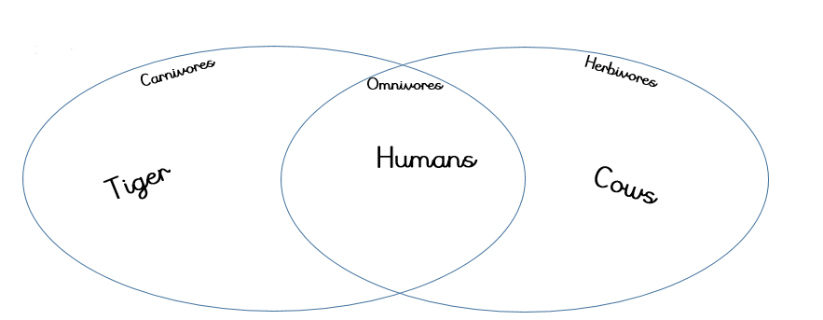  (Template at the bottom)  Tip – Correct their misconceptions about what animals eat what!
Music  5 minutes | Song of the day! Remember to move your body in time with the music. If you like, you can talk about the instruments you can hear, the way it makes you feel, your opinion, when it was made, if it reminds you of anything else. If not, just have a dance and a smile and a laugh.  (Feel free to play your own if you don’t like mine!)  The snake – Al Wilson  https://www.youtube.com/watch?v=ULx9k2QkL94  Good job everybody!

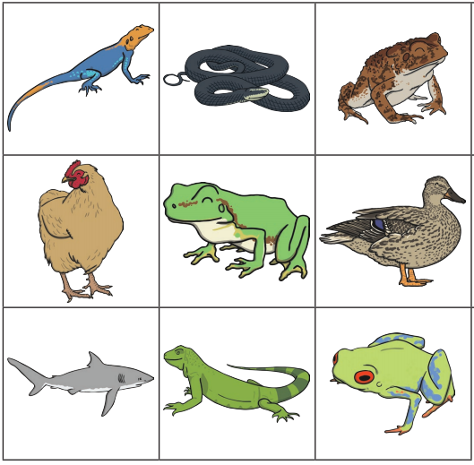
52p
33p
30p
54p
12p
25p
44p
41p
22p

Meet the Crocodile

1 When a crocodile is lying under the water, which parts of its
body can you see?

Tick two.

feet |  | eyes
teeth |  | tail
nostrils

2 Why does the crocodile beat its tail from side to side?

______________________________________________________________

3 Why does the crocodile have eyes on top of its head?

______________________________________________________________

4 Which part of the crocodile is like a frog?

Tick one.

Teeth |  | Eyes
Nostrils |  | Feet

