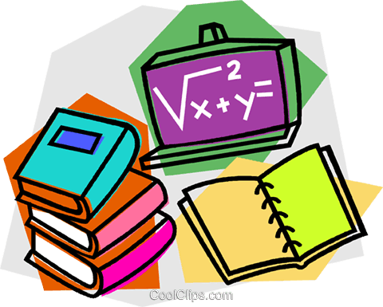
Year 2 Home Learning
27/04/20
Suggested daily timetable
9am – Morning meditation
9:05 – 9:35- Reading comprehension
9:45 – 10:00 Grammar and punctuation
10:00 – 10:30 – Writing
10:30 – 11:00 – Break and exercise
11:00 – 11:15 – Spelling/handwriting
11:15 – 11:45 - Maths
11:45 – 12:00 – Story time
12:00 – 1:30 – Lunch break.
1:30 – 2:00 – Bug club reading
2:00 – 2:30 – PE (use Joe Wick on YouTube if you aren’t already!)
2:30 – 3:15 – Curriculum.
3:15 – 3:20 - Music

Here is your Home Learning Timetable for today and an example of a daily timetable you may wish to follow. I have altered it slightly from last week to fit in time for Bug Club after lunch. There is also some music at the end of the day.. This document will give you hints and tips on how to deliver the material and exactly what they should be doing. The weekly slides are ‘child friendly’ and will guide them through the day in more simple language. I have made everything more accessible for those people who cannot get online for any reason by providing alternative suggestions for activities
Feel free to change or personalise the material. Explain anything they don’t understand in your own words and remind them it’s OK to get stuff wrong; that’s when we learn!
Please do as much or as little as you can. This is such an unusual and stressful time for many so our priority should always be the well-being of ourselves and the ones we care about.
This week’s theme is ‘animals’.
Relaxation  5 minutes | Click on the link on the slide or type this in.  https://www.youtube.com/watch?v=Uy5YgQe1o3Q  Remember: This is important for our learning. With a clear mind we can concentrate more easily!  Tip for parents – If your child feels silly doing this or doesn’t want to, join in with them!  Tip for parents – If you don’t have access to a device or the internet, sit with your child somewhere comfortable and tell them to close their eyes and take five deep breaths through their nose and out through their mouths. Ask them to focus on the little noises they can hear outside, and around your house. Tell them it’s OK if their mind wanders, just bring their thoughts round to their breathing and what they can hear.
Reading comp  30 minutes | Children to read or support them to read this poem:  (Also added as a separate sheet at the bottom).  Dogs  Dogs big, dogs small  Dogs short, dogs tall  Dogs fat, dogs thin  Dogs that make a dreadful din.  Dogs smooth, dogs hairy  Dogs friendly, dogs scary  Dogs brown, dogs white  Dogs that bark all through the night.  Dogs that run, dogs that walk  Dogs that make you think they’ll talk,  Dogs awake, dogs asleep  Dogs for the blind, dogs for the sheep.  The best of all the dogs I know  Goes with me everywhere I go.  by John Kitching  Tip – Read it twice, out loud. The first time they can concentrate on the sounds and new words. Make sure that the second time they read the story, they read it as they would ‘say’ it (using a conversational tone).  After they can answer these questions, these can be verbal answers or they could be written down or typed. Children could even draw their responses.  1 What do some dogs do all through the night?  Tick one.  sing bark  eat talk  2 Look at verse 3.  Find and copy the word that means the opposite of asleep.  ______________________________________________________________  3 What is the main idea in this poem?  Tick one.  Dogs live all over the world. Some people are afraid of dogs.  There are many different kinds of dogs. Everybody likes dogs.  4 Give two words from the poem that rhyme with each other.  1. __________________________________  2. __________________________________
Grammar and punctuation  10 minutes | Copy these sentences and add the correct punctuation:  The cat sat on the mat  Why is the cat sitting on the mat  Sit on the mat, cat  What a nice cat on that mat  Challenge: Why types of sentences are these?  Answers:  The cat sat on the mat. (Statement)  Why is the cat sitting on the mat? (Question)  Sit on the mat, cat. (Command)  What a nice cat on that mat! (Exclamation)
Writing  30 minutes | Show your child this picture (also attached to the bottom). Their job is to describe the setting in at least 10 sentences. Use the key words to help them.  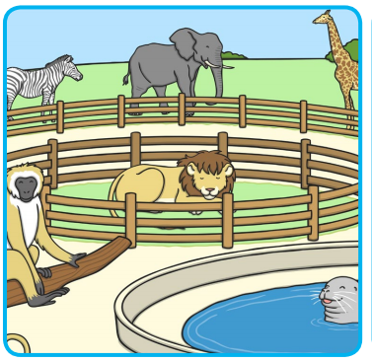  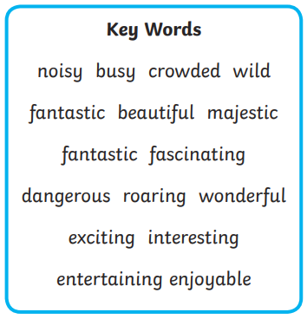  Challenge – Include an expanded noun phrase (adjective, adjective, noun, egg: ‘The big, grey elephant’. Commas only go in between the adjectives).  In year 2, when we write, we always include:  - Capital letters and full stops.  - Neat handwriting.  - Great spelling (it’s OK to ask an adult!)  - Conjunctions (only one for each sentence).  Tip – If your child’s sentences don’t make sense, encourage them to read them back out loud. In our class we: ‘Think it, say it, write it, read it’. So they think of their sentence, say their sentence out loud, write their sentence, and then read it back out loud.
Spelling and Handwriting  15 minutes | We are going to practice some common exception words that the children are expected to be able to spell by the end of year 2. Common exception words are words that ‘break the rules’ and cannot be sounded out phonetically. We will be doing 10 in total this week with a test on Friday.  Have your child either copy these words 5 times or they could use the ‘look, cover, copy’ method if they are really confident with their handwriting:  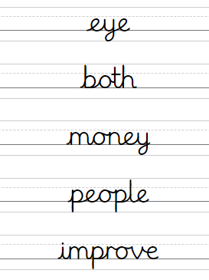  Challenge: Can you use each one in a sentence?
Maths  30 minutes | (Tip for parents) – This is recapping how to add and subtract tens to a two-digit number. Remind them that when adding a ‘tens number’ or ‘multiple of ten’ (a number that ends in a zero) to a number with two digits, the ones always stay the same.  Farmers like to buy and sell their cows in groups of 10.  If he has 35 cows and buys another 10, how many will he have? Can you write an equation for this?  35 + 10 = 45  If Giles has 35 cows but this time he sells 10, how many will he have then? Write the equation!  35 – 10 = 25  Farmer Daisy owns 48 cows. How many cows will she have if she buys:  10 cows.  20 cows.  30 cows.  40 cows.  Write the correct equations! (Tip for parents: An equation is what we would have called a sum when we were at school).  Can you see a pattern in your answers?  Farmer Jo owns 99 cows. How many cows will she have if she sells:  20 cows.  40 cows.  60 cows.  80 cows.  Write the correct equations. What’s the pattern now?  Challenge: Can you write all the equations families? For instance:  If 23 + 10 = 33, then  10 + 23 = 33  33 – 23 = 10  33 – 10 = 23
Youtube story | Clark the Shark read by Chris Pine  https://www.youtube.com/watch?v=lgZRMptA0Lk  (Or read your own book to them instead!)
Reading | Log onto ‘Bugclub’ and have the children read one of their stories. Then answer the questions about it.  - If you do not have your login let me know and I will send it to you.  - If you do not have a suitable device, choose a book that your child can read confidently and get them to read it to you. Ask them questions like “What was the story about?” “What did you think of the sotry? Why?” “What might happen after this?” “What was your favourite part?” “Does it remind you of any other stories?  Tip – Get them to read the story twice, out loud. The first time they can concentrate on the sounds and new words. Make sure that the second time they read the story, they read it as they would ‘say’ it (using a conversational tone).
PE with Joe Wicks  30 minutes | https://www.youtube.com/user/thebodycoach1  Find today’s episode and clear a space so your child can really get into it.  Join in with them if they’re feeling self-conscious!
Curriculum  45 minutes | Science:  This week we’ll be going back over animals and habitats.  Ask your child what the difference between being alive, once being alive, and never have being alive is. Give them examples.  Today’s mission. Spot at least 5 things that are alive, spot at least 5 things that were once alive and 5 things that have never been alive. Get three bits of paper, write them down and draw them on each. You could even collect them if it’s possible to do so!  Here are some examples to help:  Alive:  Someone in the house.  A pet.  A house plant.  Grass.  A tree.  A squirrel.  Once alive:  A stick.  A leaf.  Paper.  A wooden chair.  A piece of ham.  A pencil.  Never Alive:  A television.  A carpet.  A brick.  A mirror.  A shoe.  Now ask them to think about what is similar on each list. How do we know what thing belongs in which category? What do all the alive things have in common?  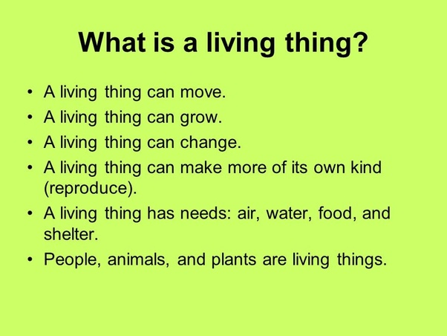  Here’s a bit of extra learning if you need it:  https://www.bbc.co.uk/bitesize/topics/z6882hv/articles/zs73r82
Music  5 minutes | Song of the day! Remember to move your body in time with the music. If you like, you can talk about the instruments you can here, the way it makes you feel, your opinion, when it was made, if it reminds you of anything else. If not, just have a dance and a smile and a laugh.  (Feel free to play your own if you don’t like mine!)  https://www.youtube.com/watch?v=OQlByoPdG6c  Good job everybody!

Dogs

Dogs big, dogs small
Dogs short, dogs tall
Dogs fat, dogs thin
Dogs that make a dreadful din.

Dogs smooth, dogs hairy
Dogs friendly, dogs scary
Dogs brown, dogs white
Dogs that bark all through the night.
Dogs that run, dogs that walk  Dogs that make you think they’ll talk,  Dogs awake, dogs asleep  Dogs for the blind, dogs for the sheep.  The best of all the dogs I know  Goes with me everywhere I go.  by John Kitching | 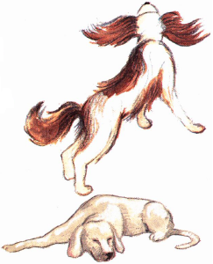

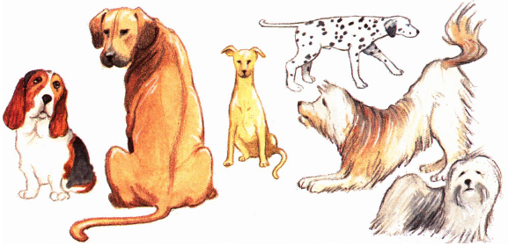

1 What do some dogs do all through the night?

Tick one.

sing |  | bark
eat |  | talk

2 Look at verse 3.

Find and copy the word that means the opposite of asleep.

______________________________________________________________

3 What is the main idea in this poem?

Tick one.

Dogs live all over the world. |  | Some people are afraid of dogs.
There are many different kinds of dogs. |  | Everybody likes dogs.

4 Give two words from the poem that rhyme with each other.

1. __________________________________

2. __________________________________

