Year 2 Home Learning
30/04/20
Suggested daily timetable
9am – Morning meditation
9:05 – 9:35- Reading comprehension
9:45 – 10:00 Grammar and punctuation
10:00 – 10:30 – Writing
10:30 – 11:00 – Break and exercise
11:00 – 11:15 – Spelling/handwriting
11:15 – 11:45 - Maths
11:45 – 12:00 – Story time
12:00 – 1:30 – Lunch break.
1:30 – 2:00 – Bug club reading
2:00 – 2:30 – PE (use Joe Wick on YouTube if you aren’t already!)
2:30 – 3:15 – Curriculum.
3:15 – 3:20 - Music

Here is your Home Learning Timetable for today and an example of a daily timetable you may wish to follow. I have altered it slightly from last week to fit in time for Bug Club after lunch. There is also some music at the end of the day. This document will give you hints and tips on how to deliver the material and exactly what they should be doing. The weekly slides are ‘child friendly’ and will guide them through the day in more simple language. I have made everything more accessible for those people who cannot get online for any reason by providing alternative suggestions for activities
Feel free to change or personalise the material. Explain anything they don’t understand in your own words and remind them it’s OK to get stuff wrong; that’s when we learn!
Please do as much or as little as you can. This is such an unusual and stressful time for many so our priority should always be the well-being of ourselves and the ones we care about.
This week’s theme is ‘animals’.
Relaxation  5 minutes | Click on the link on the slide or type this in.  https://www.youtube.com/watch?v=06wtmoB1trY  Remember: This is important for our learning. With a clear mind we can concentrate more easily!  Tip for parents – If your child feels silly doing this or doesn’t want to, join in with them!  Tip for parents – If you don’t have access to a device or the internet, sit with your child somewhere comfortable and tell them to close their eyes and take five deep breaths through their nose and out through their mouths. Ask them to focus on the little noises they can hear outside, and around your house. Tell them it’s OK if their mind wanders, just bring their thoughts round to their breathing and what they can hear.
Reading comp  30 minutes | Have your child look carefully at the text. Get them to read each part to you or read it with them then answer the questions about it.  Cobweb morning  Most of the time, spiders’ webs are almost invisible. But sometimes, if it is frosty or damp, you can see the webs almost everywhere you look. This is because ice or water drops have stuck to the fine threads of the webs.  On a Monday morning  We do spellings and maths.  And silent reading.  But on the Monday  After the frost  We went straight outside.  Cobwebs hung in the cold air,  Everywhere.  All around the playground,  They clothed the trees,  Dressed every bush  In veils of fine white lace.  Each web,  A wheel of patient spinning.  Each spider,  Hidden,  Waiting.  Inside,  We worked all morning  To capture the outside.  Now  In our patterns and poems  We remember  The cobweb morning.  1 The children saw the cobwebs in...  Tick one.  a park  a street  a garden  a playground.  2 (a) What did the children usually learn on a Monday morning?  (b) What did the children learn about this Monday morning when they went outside?  3 The poem explains how cold weather…  Tick one.  damages cobwebs.  changes how cobwebs look.  makes cobwebs stronger.  helps spiders to make webs.
Grammar and punctuation  10 minutes | Copy these sentences and add adverbs.  The lion roared.  The cheetah ran down the hill.  The eagle flew over the mountain.  Here are some suggested answers:  The lion roared loudly.  The cheetah ran quickly down the hill.  The eagle flew majestically over the mountain.  Tip: Adverbs describe verbs, which are ‘doing’ words (like jump or think). Adverbs often end in ‘ly’ (like slowly, thoughtfully, ferociously).
Writing  30 minutes | Remind your child that yesterday we practiced writing command sentences that all began with verbs.  Ask them on what piece of writing we might find command sentences?  Steer them towards recipes and instructions!  What animal would make the best pet?  Today’s writing task is to write a set of instructions for looking after a dream pet (the wackier the better).  Most sentences should be commands.  Get them to use bullet points for their list of instructions.  Challenge: Write a descriptive sentence about your dream pet.  In year 2, when we write, we always include:  - Capital letters and full stops.  - Neat handwriting.  - Great spelling (it’s OK to ask an adult!)  - Conjunctions (only one for each sentence).  Tip – If your child’s sentences don’t make sense, encourage them to read them back out loud. In our class we: ‘Think it, say it, write it, read it’. So they think of their sentence, say their sentence out loud, write their sentence, and then read it back out loud.
Spelling  15 minutes | See if your child has managed to remember the spellings:  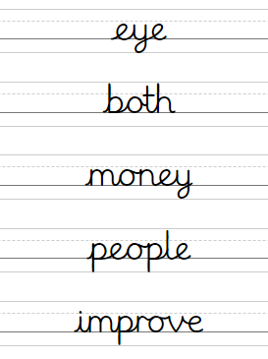  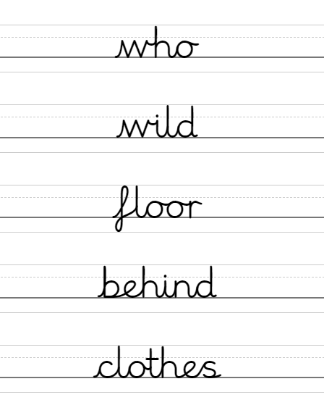  Tip – Go through the answers and correct their mistakes with them. If they don’t do well remind them that they are tricky words and it’s just about practice.
Maths  30 minutes | (Tip for parents) – This is recapping how to subtract two 2-digit numbers from each other that do ‘bridge ten’. The method we use is just like adding, subtract the tens of each number and then count down the ones.  Mrs Wilkins has change the rules again! Now you’re only allowed to buy one animal  You have 64p to spend.  How much change would you have if you bought each animal?  Write the equation for each one:  Example: 64p – 36p = 28p  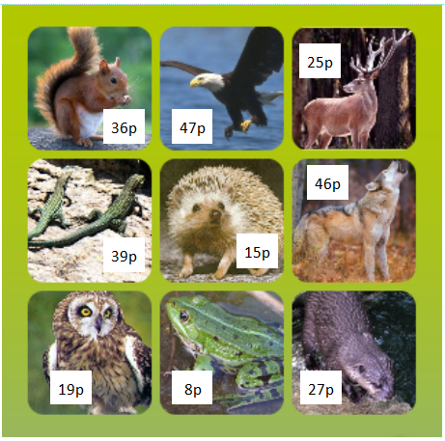  Challenge: Write the equation families for each one.  64 – 36 = 28, so  64 – 28 = 36  28 + 36 = 64  36 + 28 = 64
Youtube story | Sam And Mark - The Lion Inside  https://www.youtube.com/watch?v=IYgfyfdaT_k  (Or read your own book to them instead!)
Reading | Log onto ‘Bugclub’ and have the children read one of their stories. Then answer the questions about it.  - If you do not have your login let me know and I will send it to you.  - If you do not have a suitable device, choose a book that your child can read confidently and get them to read it to you. Ask them questions like “What was the story about?” “What did you think of the story? Why?” “What might happen after this?” “What was your favourite part?” “Does it remind you of any other stories?  Tip – Get them to read the story twice, out loud. The first time they can concentrate on the sounds and new words. Make sure that the second time they read the story, they read it as they would ‘say’ it (using a conversational tone).
PE with Joe Wicks  30 minutes | https://www.youtube.com/user/thebodycoach1  Find today’s episode and clear a space so your child can really get into it.  Join in with them if they’re feeling self-conscious!  If you can’t access this then get your child to do some exercise that will raise their heart-rate and get them out of breath. Set them a challenge, race them down the street, do a dance, do some aerobics… anything you can think of!
Curriculum  45 minutes | Ask your child this question?  Why doesn’t a polar bear live in the desert?  Animals have adapted over millions of years so they can live well in their habitats.  On a piece of paper, get your child to write full sentence answers to these questions and explain their thinking.  Tip – Tell them ‘because’ is the magic word! To make it more fun, get them to draw each animal in their strange habitat after they finish!.  Why doesn’t a polar bear live in the desert?  Where does a polar bear live?  What is special about a polar bear that makes it perfect for this environment?  Why doesn’t a camel live in Antartica?  Where does a camel live?  What is special about a polar bear that makes it perfect for this environment?  Why doesn’t a whale live in the mountains?  Where does a whale live?  What is special about a whale that makes it perfect for this environment?  Challenge: Write your own questions similar to the ones above and challenge an adult to answer them!
Music  5 minutes | Song of the day! Remember to move your body in time with the music. If you like, you can talk about the instruments you can hear, the way it makes you feel, your opinion, when it was made, if it reminds you of anything else. If not, just have a dance and a smile and a laugh.  (Feel free to play your own if you don’t like mine!)  Everybody wants to be a cat – The Aristocats  https://www.youtube.com/watch?v=4rrXR6n0RTY  Good job everybody!

Cobweb Morning

Most of the time, spiders’ webs are almost invisible. But sometimes, if it is frosty or damp, you can see the webs almost everywhere you look. This is because ice or water drops have stuck to the fine threads of the webs.

On a Monday morning

We do spellings and maths.

And silent reading.

But on the Monday

After the frost

We went straight outside.

Cobwebs hung in the cold air,

Everywhere.

All around the playground,

They clothed the trees,

Dressed every bush

In veils of fine white lace.

Each web,

A wheel of patient spinning.

Each spider,

Hidden,

Waiting.

Inside,

We worked all morning

To capture the outside.

Now

In our patterns and poems

We remember

The cobweb morning.

1 The children saw the cobwebs in...

Tick one.
a park
a street
a garden
a playground.

2 (a) What did the children usually learn on a Monday morning?

____________________________________________________________

____________________________________________________________

(b) What did the children learn about this Monday morning when they went outside?

____________________________________________________________

____________________________________________________________

3 The poem explains how cold weather…

Tick one.
damages cobwebs.
changes how cobwebs look.
makes cobwebs stronger.
helps spiders to make webs.

