Counting Using Negative Numbers
You can count back from 10 in 2s by taking away 2 each time:
1
3
5
7
8
6
4
2
0
9 10 11
–11–10 –9 –8 –7 –6 –5 –4 –3
–2 –1
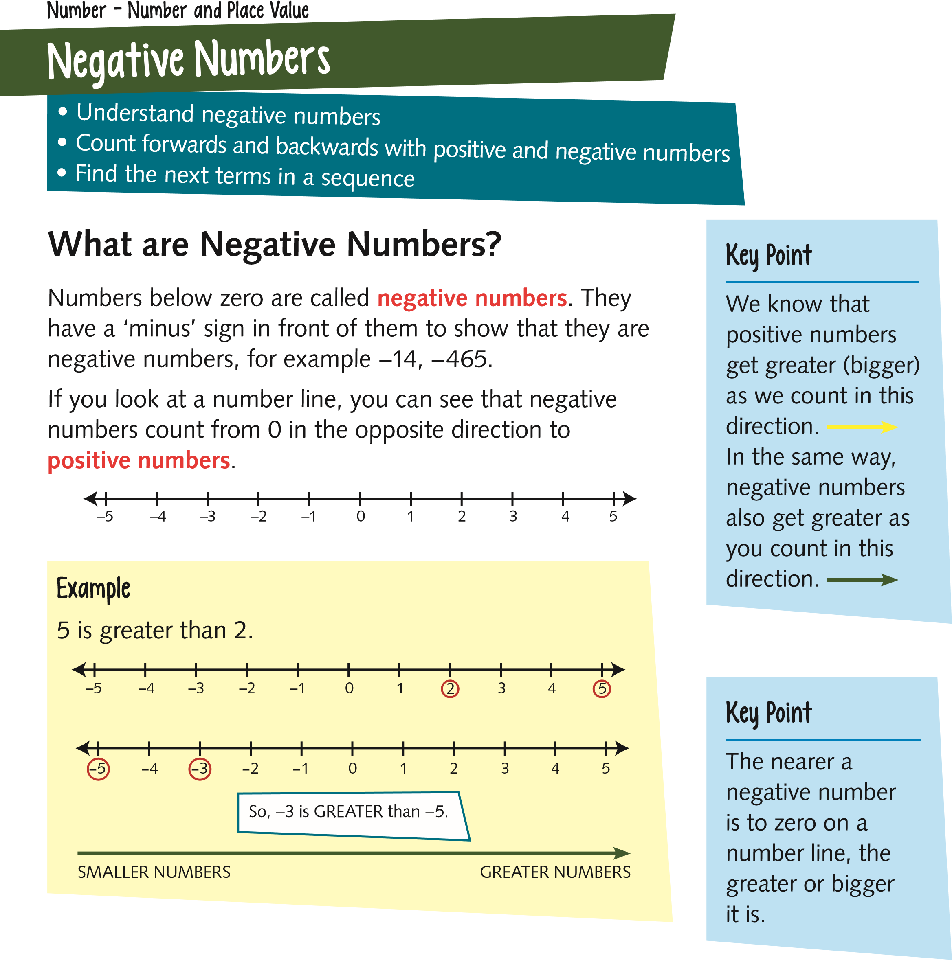
If you continue to count back in 2s, you can go beyond zero into negative numbers.
8
1
3
5
7
6
4
2
0
9 10 11
–11 –10 –9 –8 –7 –6 –5 –4 –3 –2 –1
6

Counting Sequences
You can count on or back from any number in equal steps. This is called a sequence.
You need to be able to count on or back from any number in jumps of any size.

Example
Counting from 5 in steps of 4: 5, 9, 13, 17…
Study
Count back in 100s from 953: 953, 853, 753…
Sometimes you are not given the steps.
Example
What are the next three
terms
or numbers in
this sequence?
, 10, 16,
4

First you need to work out the jump between each
number in our sequence.
4 10 16
+6 +6
4 10 16 22 28 34
+6 +6 +6 +6
+6
To jump from 4 to 10, you add 6.
To jump from 10 to 16, you add 6.
You can find the next terms by
adding 6 each time.
7
Quick Test
1.
Order these numbers from smallest to largest:
10
−3 5 −9 6 −2 0
−5

2.
Fill in the next three terms counting back in 3s:

4
1 −2

3.
Fill in the next three terms counting on in 50s:

−50
0

Key Words
•
Negative number
•
Positive number
•
Sequence
•
Term

Tip
Always check your arithmetic carefully when counting on and back – it’s easy to make mistakes!

