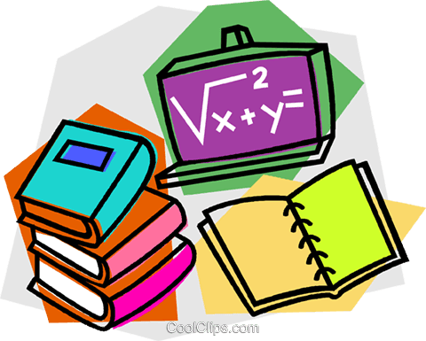
Year 2 Home Learning
Friday

If you would like extra activities then contact me and I’ll be happy to direct you. I have included useful links for further learning below again.

My email address: Oak-Year2.Support@OasisNewOak.org
‘Draw With Rob’: Excellent and fun cartoon drawing tutorials. http://www.robbiddulph.com/draw-with-rob
‘Bugclub’: https://www.activelearnprimary.co.uk/login?e=-1&c=0
‘Times table rock stars’: https://ttrockstars.com/
‘Karate cats’: The kids love these grammar and maths games. https://www.bbc.co.uk/bitesize/topics/zd63xyc/articles/zdp4pg8
https://www.bbc.co.uk/bitesize/topics/zjkphbk/articles/zf4sscw
‘Spotify’: I’m sure you know about this one already but just in case, access almost every song ever written. Show your kids the music you love! https://open.spotify.com/
‘BBC Bitesize’ has all different types of learning for all different ages: https://www.bbc.co.uk/bitesize
‘Math aids’: Personalised maths work sheets. https://www.math-aids.com/
‘The literacy shed’: Awesome writing stimuluses. https://www.literacyshed.com/home.html
Here is a guide to the best online PE resources: https://www.weareteachers.com/virtual-pe-classes/

Reading Comprehension
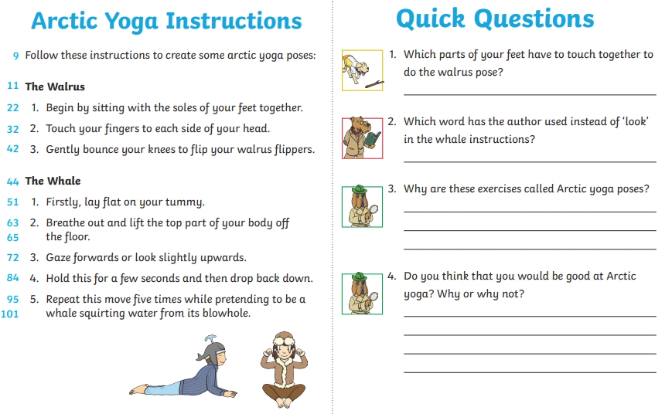
Phonics

Write down and say as many different words with the diagraph ‘o_e’ in them as you can! Use lots of different colours and write them in the box. Start with ‘bone’.

Boat

Grammar and punctuation
Q1.

Why does the underlined word start with a capital letter in the sentence below?
Dad cleaned the kitchen and Joe helped.
___________________________________________________________________
Q2.
What is the sentence below? The end punctuation is covered.
What a fantastic piece of work that is

Tick one.
a statement
a command
an exclamation
a question
Q3.
Write a command a teacher could say at the end of playtime.
Remember to use correct punctuation.

Spelling
I want you to practice our common exception words. How many of them can you spell already? Can you learn to spell them all by the holiday?
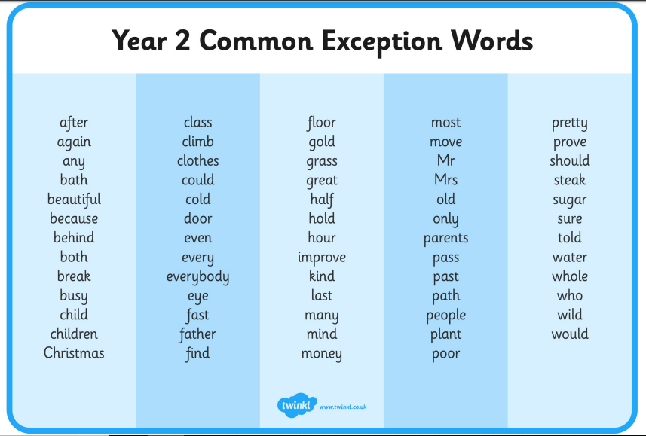

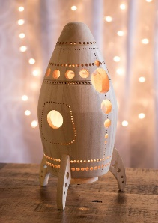
Writing
Today your job is to write the story that you planned during day 1 about a child who finds a spaceship.
Remember to use capital letters and full stops, neat handwriting, checked spelling and one conjunction per sentence (like and, because, or).
___________________________________________________________________________________________________________________________________________________________________________________________________________________________________________________________________________________________________________________________________________________________________________________________________________________________________________________________________________________________________________________________________________________________________________________________________________________________________________________________________________________________________________________________________________________________________________________________________________________________________________________________________________________________________________________________________________________________________
Maths
Count how many of each thing there is on the sheet then answer the questions.

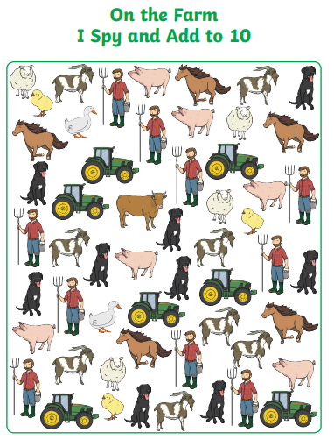
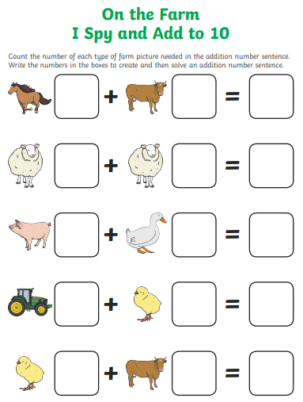
Curriculum

This week I will be providing you of a list of things you might want to do during your curriculum time. Choose one or many, make sure you enjoy it!

Science:
- Make a list of objects and the materials they are made out of.
- Build a bridge out of paper. How does the shape help its strength?
- Research one of the following habitats online and make a fact-file: Polar, desert, ocean, forest.
- Spend some time on a walk doing an animal search. Can you here one? Can you see one? What type of animal is it? How do you know? How is it different to other animals? Is it a mammal, reptile, bird, fish or amphibian?
- Write a weather prediction. What will the weather be like tomorrow? What will it be like in a week?

Geography:
- Practice memorising the capital cities of as many countries as you can.
- Practice memorising the flags of as many countries as you can.
- Use Google maps or Google Earth to find: Your house, our school, Bristol, London, The Pacific Ocean, Kenya, The Grand Canyon, The Great Wall of China.

History:
- Research The Great Fire of London to remind yourself what we learnt about it.
- Find out what Bristol was like 50 years ago. Do you know anyone over 50 you could phone or talk to in person? How else might you find out?
Music:
- Make up a song.
- Learn the words to a song and sing it off by heart.

Art:
- Make a picture using as many different ways of colouring as you can think of. Paints, chalk, pencils etc.
- Use a computer to create a picture of a person you love.
- Draw your favourite type of animal using only two colours.

PE:
- Run one kilometre (with an adult) and time yourselves. Can you beat your record?
- Practice balancing things on your head. Make sure they aren’t things that will break or hurt you if they fall!

