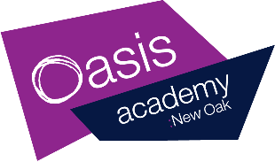
Year 1 Home Learning – Friday
Story time:
https://www.youtube.com/watch?v=Hrd-Wdxbg-Q

Phonics  30 minutes | The sound of the day today is…  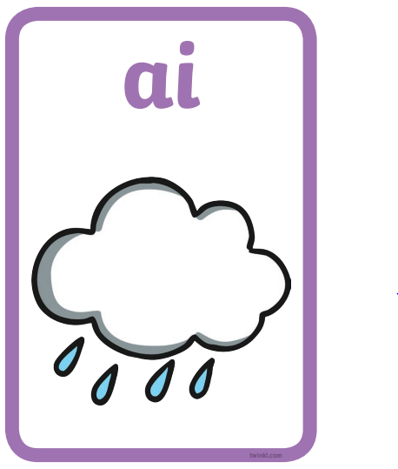 Please watch the phonics lesson video (children should be able to complete this independently)  https://www.youtube.com/watch?v=zwZTlm4Ze-k&list=PLhiNWfuSxAu2B8X8UKwpomGwmPzlaaTBr&index=16  Can you now play the roll and read game? You need to roll a dice and read the word that the dice lands on! Good luck…  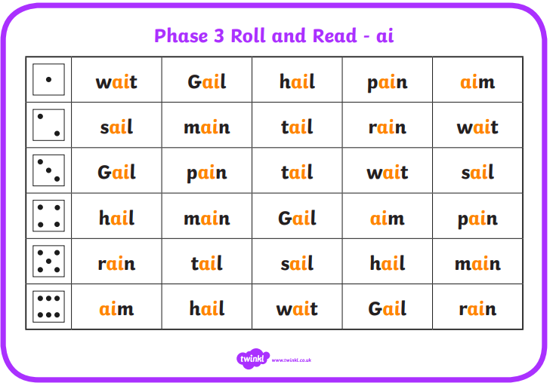  Phonicsplay.co.uk are offering free subscriptions at the moment. The site has lots of phonic activities and games for children to play to consolidate their phonetic knowledge which can be used on tablets and laptops. Every day as our phonic lesson warm up in class, we use the ‘flashcard speed trials’. If you pick all sounds, then the children say the sound as they arrive on the screen and then you click the ‘c’ button to move on to the next. Children should be really familiar with the game. We usually time the game and see each day if we can beat our score!  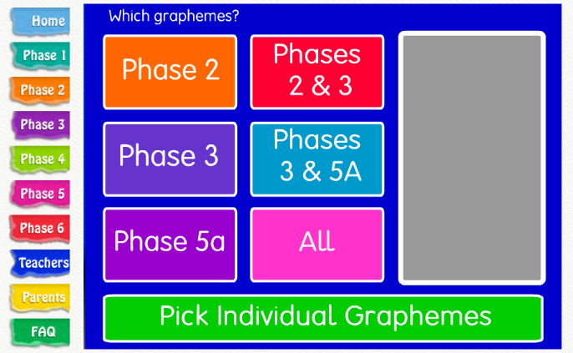  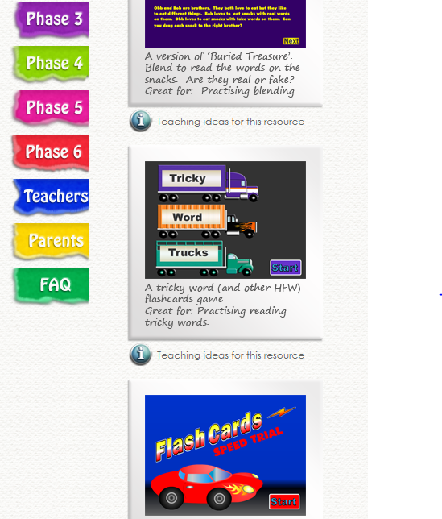
Writing  30 minutes-  To design a sea character.  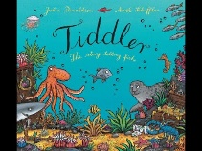 | Your job today is to write a character description using your sea creature you created yesterday. I would like you try and use finger spaces, full stops and capital letters in your sentence.  You are going to use adjectives to describe your character.  Adjectives - An adjective is a word that describes a noun (the name of a thing or a place).  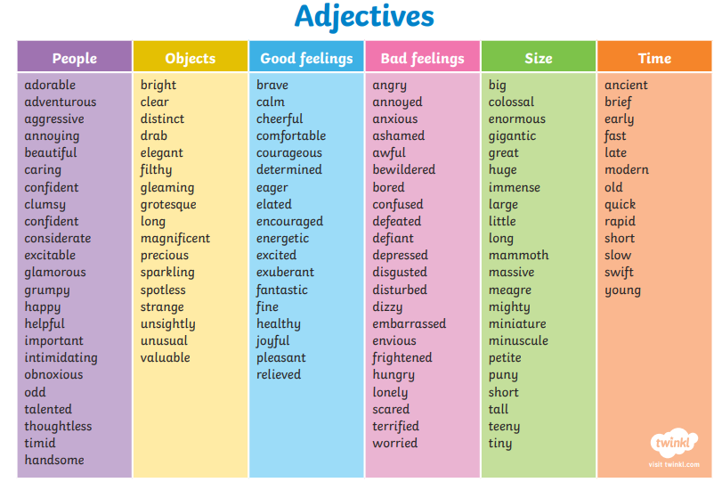  Once you have chosen adjectives to describe your character, you need to add these into a sentence.. Can you try and write 2 sentences using some of the words. You might even use 2 in one sentence:  E.g  ‘My Sea Monster is blue’  ‘My Sea Monster is fluffy and long.’  Don’t forget to say your sentence out loud before writing it.  Your turn…  Here is a clip of blue planet to help you create your under sea creature:  https://www.youtube.com/watch?v=LnOYpuKV4H4
Handwriting/  Spelling  10 minutes | Children can practise their handwriting using cursive letters.  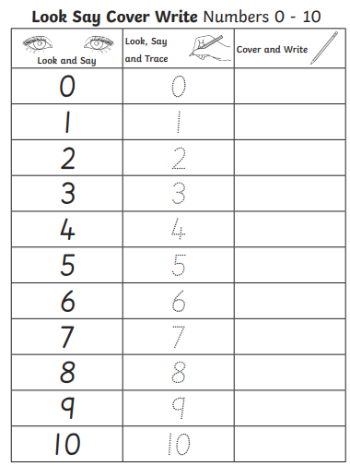
Maths  30 minutes | The objective of today is ‘To describe and sort 2D shapes’.  Starter: Can you count in twos to 50.  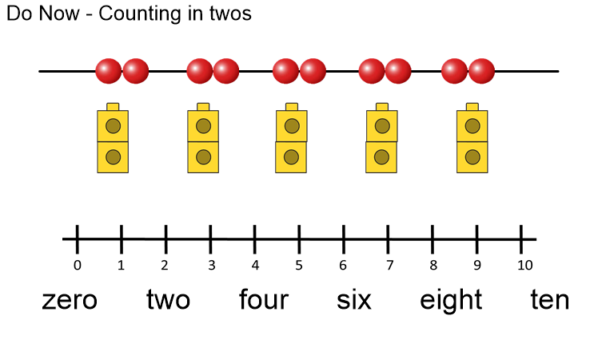  Star words (these are words that children need to use in full sentences when answering questions):  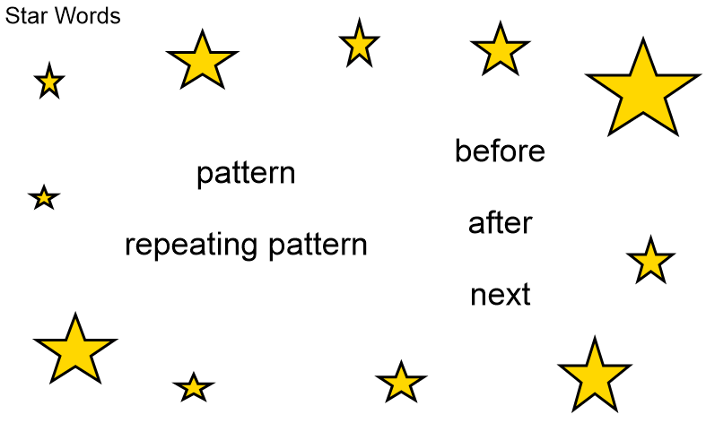  Main teaching:  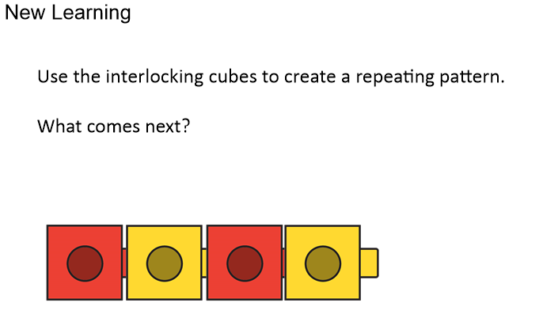  ? The pattern is triangle, circle, and triangle. What will be next in the pattern?  Your task today is to go on a shape walk. This could be in your home, garden or outdoor area. I would like you to look out for different shapes around and tally these on the sheet below:  What do you think comes next in these repeating patterns?  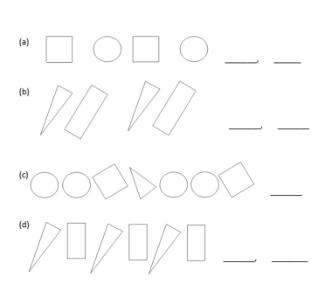  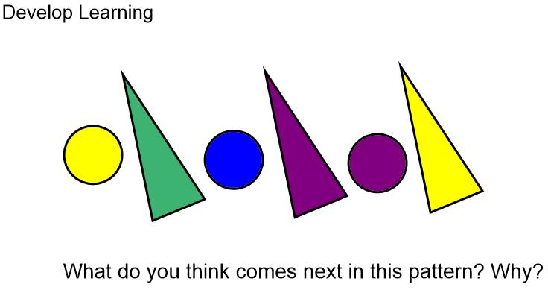  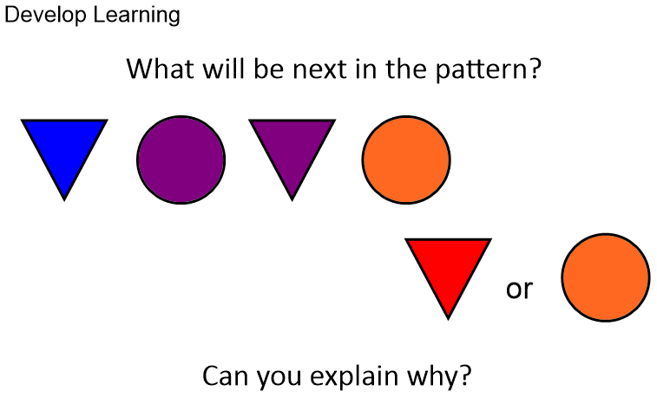  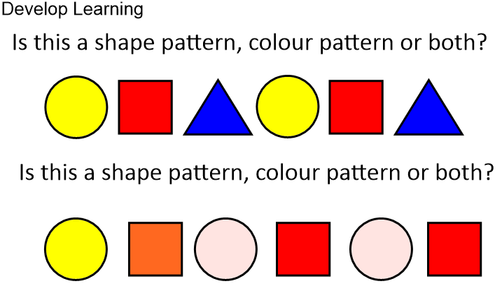   The pattern is circle, triangle, circle, triangle, circle, triangle. The next shape will be circle.  Explain that it does not matter that the triangles are different colours because it is not a colour pattern.  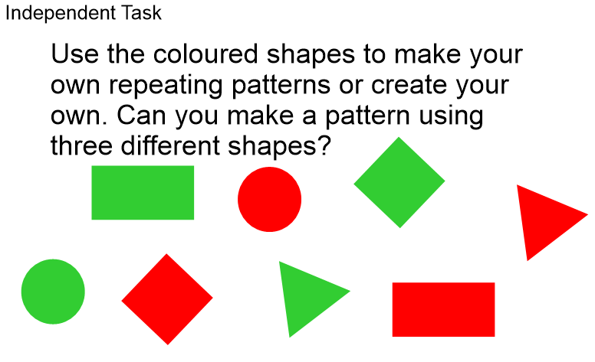  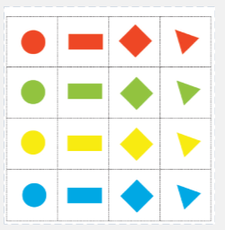 (have attached at the bottom of this home learning if you wish to cut these out)  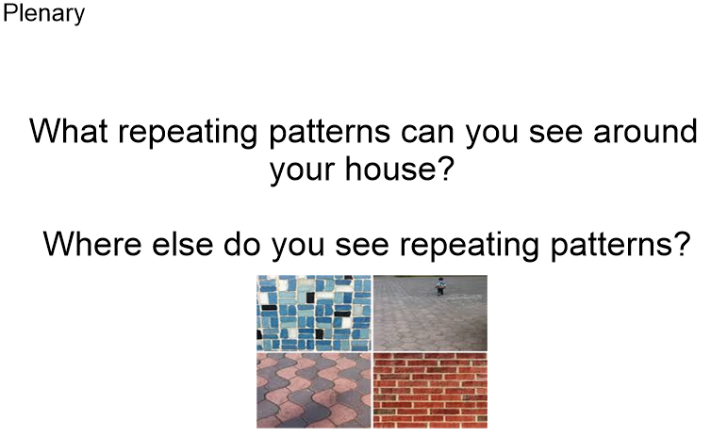
Enquiry  30 minutes. | This week Elephants you have been looking at the weather. Today is the day when I would like you to tell me the information you have gathered throughout the week. This could be in some kind of presentation, poster, pictures, voice recordings, video or drawings. I would like you to try and tell me what the rain fall has been like, how windy has it been and what the temperature has been like.  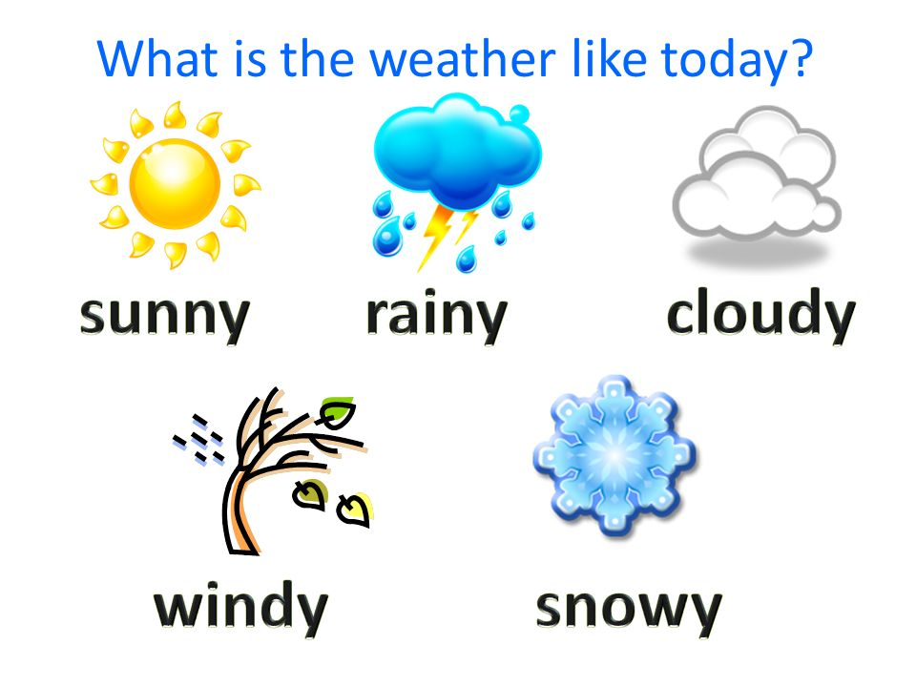
Reading | Read an e-book on Bug Club and answer the comprehension questions.  