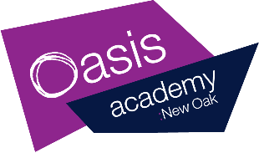
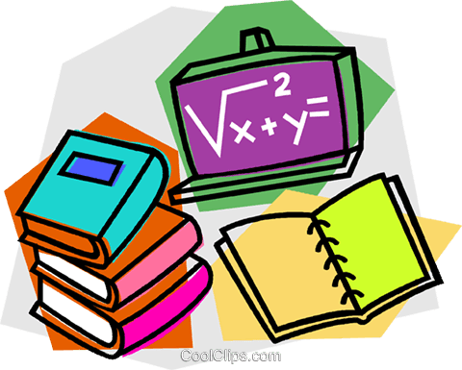
Year 1 Home Learning – Thursday 30th April 2020.

This is your home learning plan for today. Feel free to twist and change it to accommodate to your family and home life. Some activities may be adapted for younger and older children to join in. Please do as much or as little as you can. This is an unusual and stressful time, my main priority is that you and your families are happy and healthy.

Phonics  30 minutes  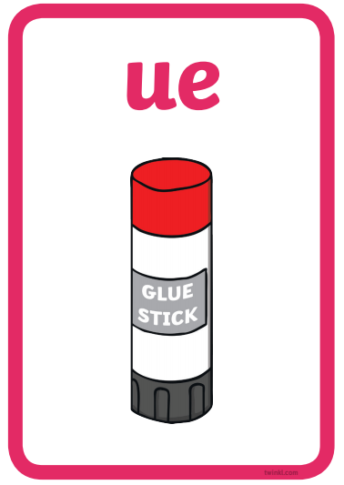 | Starter:  Can you think of any words that contain the clusters below?  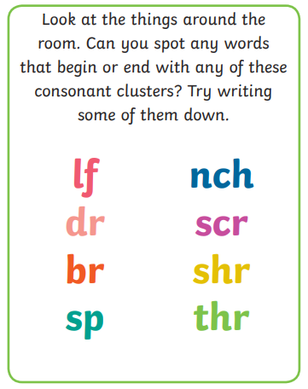  Learning sound:  - Can you remember the sound ‘ue’? What other ways can you write the ‘ue’ digraph?  - This digraph makes two sounds:  - Can you think of any words that contain the ‘ue’ digraph? (ue as in glue (oo)).  - Can you think of any words that contain the ‘ue’ digraph? (ue as in queue (u)).  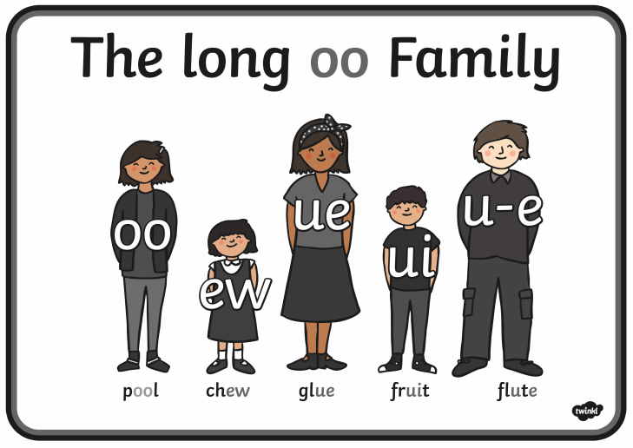  Watch the clip: https://www.youtube.com/watch?v=BCeE3B_tAq8 type into the search bar on youtube ‘Geraldine Giraffe learns /ue/’  - Can you read these 4 words containing the ‘ue’ digraph? Don’t forget to add your sound buttons onto the words to help.  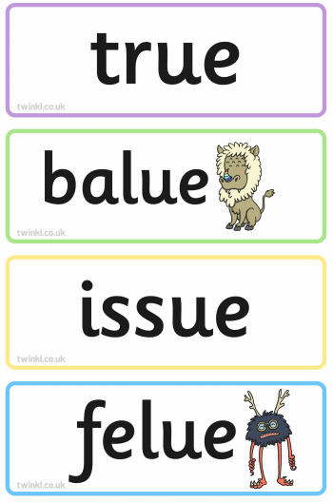  - Can you write 2 words that contain the ‘ue’ digraph? (tissue, statue)  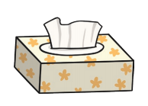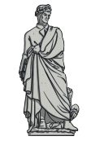  - Can you read this sentence and draw a picture to match the sentence?  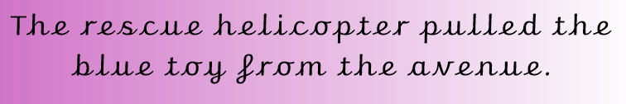  - Can you now think of any other words containing the ‘ue’ digraph and use them in a silly sentence? Here are some pictures to help! (glue, argue and clue)  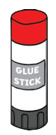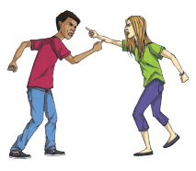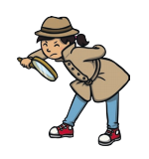  _________________________________________________________________  _________________________________________________________________  Plenary:  Can you read the postcard below:  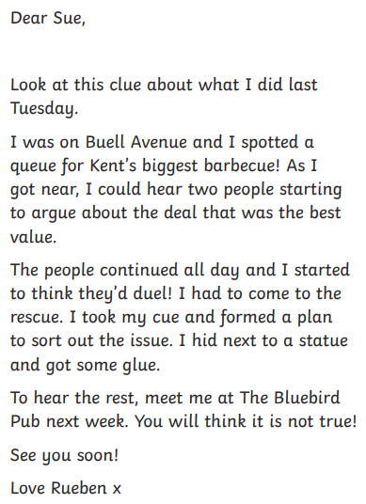
Writing  30 minutes | We are still looking at the book ’10 things I can do to help my world.’ https://www.youtube.com/watch?v=xTN6T74W4L8  The task from the rest of the week is to create a letter. Over the next few days I would like you write an introduction, middle and ending. Think back to when you wrote a letter to Bristol Zoo about the animals because they had all been mixed up into the wrong cages.  Can you re-read the introduction you started yesterday?  I would like you to write a letter to me! I think we could do more in school to help our world and I was hoping that you could write a letter to me to tell me how. I imagine you have lots of ideas on ways we can look after our world better in school. Think of the ways in the book that we can help our world and how do you think we could do some of these in our classroom.  Here are some ideas:  - Put fruit ends in a food waste bin.  - Put milk cartons in recycling.  - Turn the lights off when we go to play and lunch.  - Walk to school instead of driving.  - Use both sides of the paper when we are writing and recycle after.  - Use energy saving light bulbs.  - We could grow our own fruit and vegetables for snack.  Today you are going to write the middle part to your letter. This is the part where you are going to tell me what you are going to do to try and help our world or what you would like to do. Above are some ideas to help you. Try and put these into a sentence you might even try to use a conjunctions (because) or adjective to make the letters as exciting as possible.  Example:  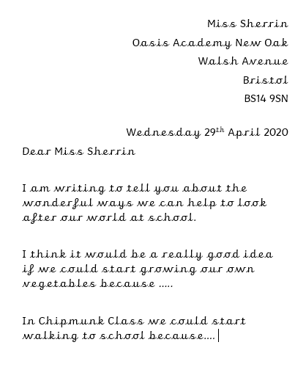  Don’t forget:  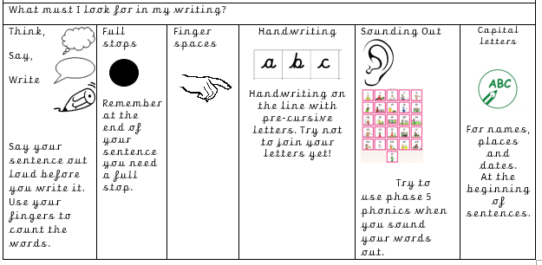
Handwriting  10 minutes | Children can practise their handwriting using cursive letters. If you would like to be more creative you could practise letter formation using sand (flour, salt or anything you have in the house) in tray or on the ground and get children to use their fingers to create the letters.  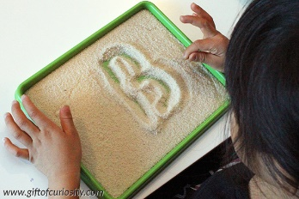  Practice:  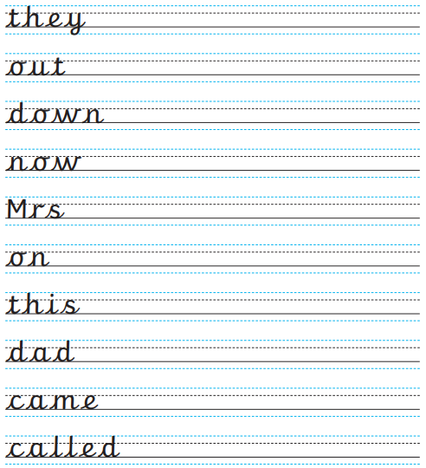
Maths  30 minutes | This week we are going to recap the work we have previously done this year on time. The objective of today is ‘To read the time to half past and ‘clock’. So far this week we have revised our knowledge of telling the time. Today we are going to mix the two together so be extra careful when looking at the clock hands.  Starter: Can you match the clocks to the time?  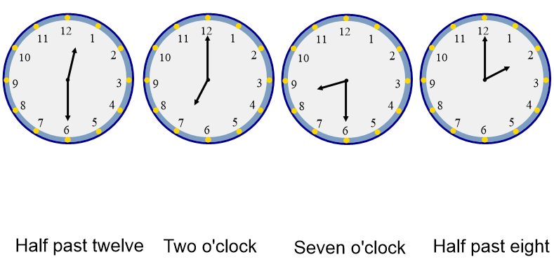  Star words (these are words that children need to use in full sentences when answering questions):  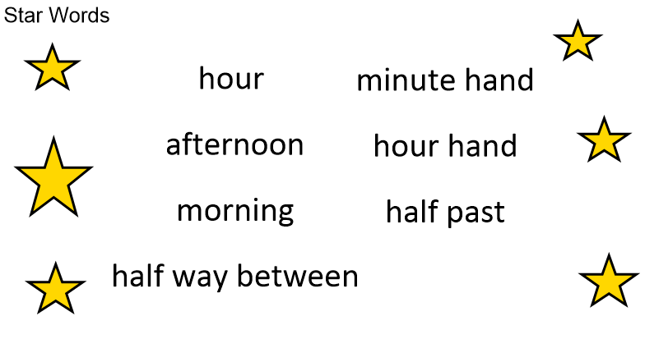  Main teaching:  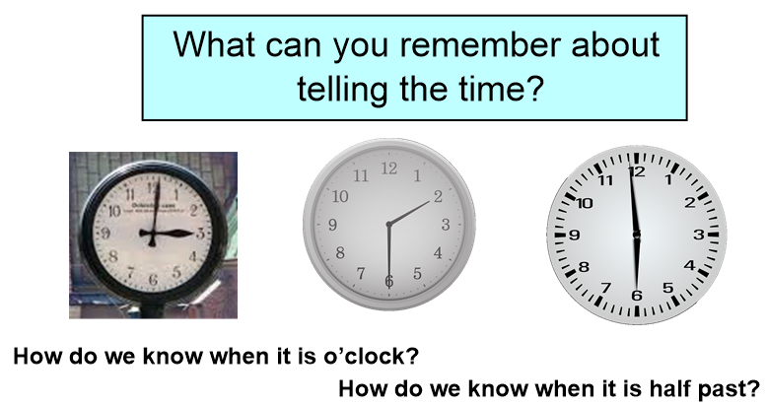  ? What can you remember about telling the time?   We tell the time using the hour hand. The hour hand is the short hand and the long hand is called the minute hand. When the minute hand is pointing straight up it is o’clock. When the minute hand is pointing straight down it is half past. When it is o’clock, the hour hand will be pointing to a numeral. When it is half past, the hour hand will be halfway between two numerals.  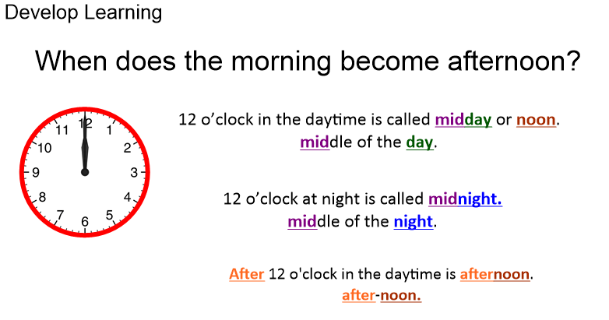  Children have the four pictures below and they need to draw the times on the clock to show when it might happen. Then they complete the sentence ‘It is ________ in the __________ (morning or afternoon).  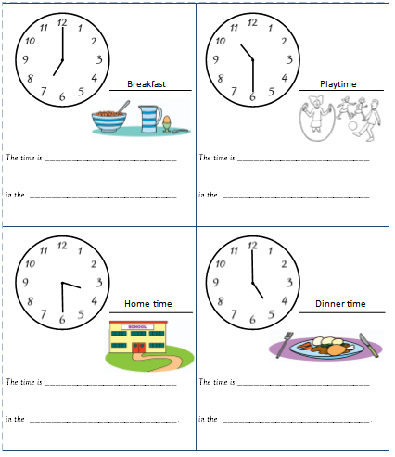  Plenary:  Can you solve the problem below?  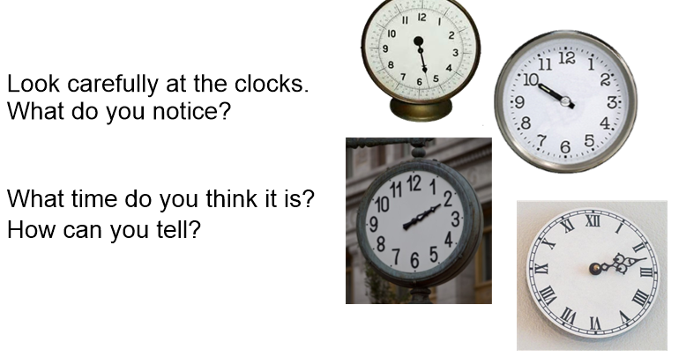
Enquiry  30 minutes.  Art | With Mrs Tarling you have done lots of work on our location in Geography. Today’s afternoon mission is to try and create a map of where you live and the things around you. This may be your house in the middle, a park nearby, the shops or school. If you have a grown up to help you they might be able to show you on google maps! Once you have drawn your map can you label the different places?  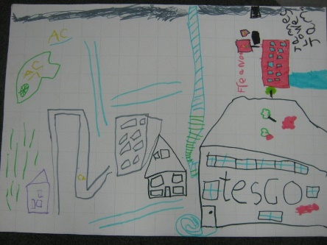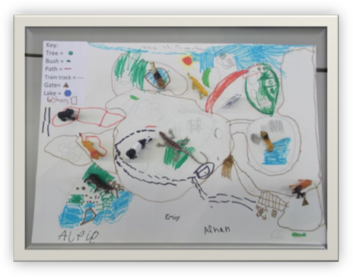
Reading | Read an e-book on Bug Club and answer the comprehension questions.  