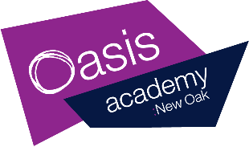
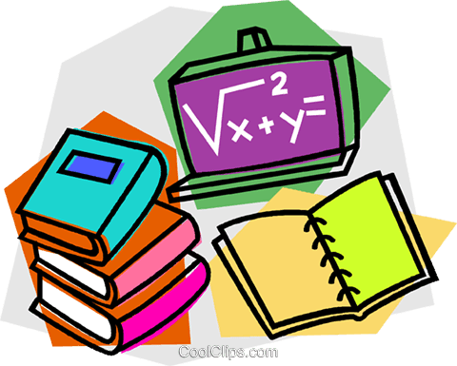
Year 1 Home Learning – Friday 1st May 2020.

This is your home learning plan for today. Feel free to twist and change it to accommodate to your family and home life. Some activities may be adapted for younger and older children to join in. Please do as much or as little as you can. This is an unusual and stressful time, my main priority is that you and your families are happy and healthy.

Phonics  30 minutes | Starter:  Today we are going to revisit the sounds learnt this week.  Can you think of one or two words for each of the sounds?  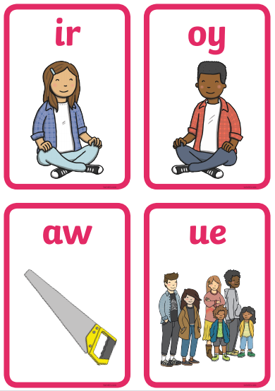  Learning sound:  Adults can you write the following words on a piece of paper and put them around the house. Children then go and find the words around the house and read them once they are found.  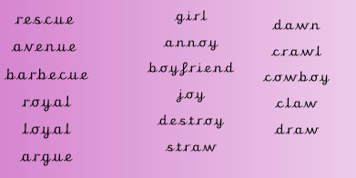  Once you have found all the words. Can you try and write 4 sentences using some of the words. You might even use 2 in one sentence:  E.g  ‘I will rescue the girl from the cowboy.’  Your turn…
Writing  30 minutes | We are still looking at the book ’10 things I can do to help my world.’ https://www.youtube.com/watch?v=xTN6T74W4L8  The task from the rest of the week is to create a letter. Over the next few days I would like you write an introduction, middle and ending. Think back to when you wrote a letter to Bristol Zoo about the animals because they had all been mixed up into the wrong cages.  Can you re-read the letter so far?  I would like you to write a letter to me! I think we could do more in school to help our world and I was hoping that you could write a letter to me to tell me how. I imagine you have lots of ideas on ways we can look after our world better in school. Think of the ways in the book that we can help our world and how do you think we could do some of these in our classroom.  Here are some ideas:  - Put fruit ends in a food waste bin.  - Put milk cartons in recycling.  - Turn the lights off when we go to play and lunch.  - Walk to school instead of driving.  - Use both sides of the paper when we are writing and recycle after.  - Use energy saving light bulbs.  - We could grow our own fruit and vegetables for snack.  Today you are going to write the end of your letter. This last bit of the letter is the closing part. I want you to think about how we could do it and maybe tell me when and how we could start these ideas. Don’t forget to write your name at the end so I know who it is from!  Example:  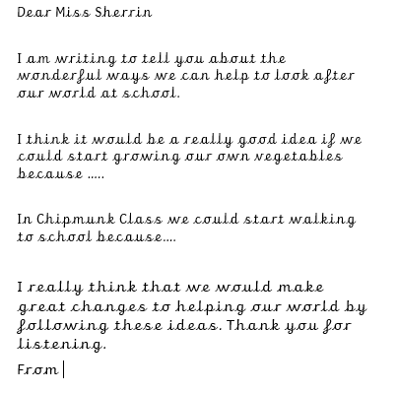  Don’t forget:  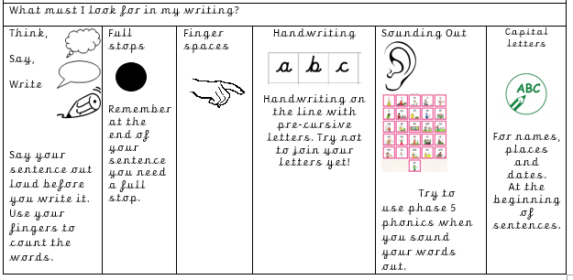
Handwriting  10 minutes | Children can practise their handwriting using cursive letters. If you would like to be more creative you could practise letter formation using sand (flour, salt or anything you have in the house) in tray or on the ground and get children to use their fingers to create the letters.  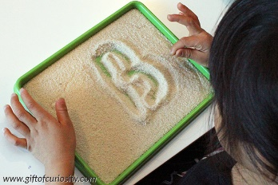  Practice:  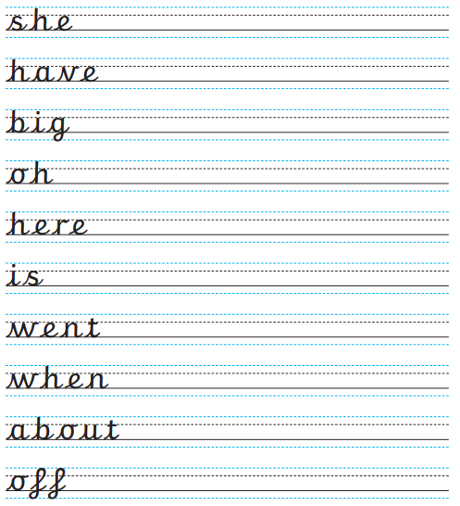
Maths  30 minutes | This week we are going to recap the work we have previously done this year on time. Today we are think about all we have learnt this week. Your maths mission is to write your daily schedule this can be your routine while you are at home or your day in school.  I would like you to write the time or draw the hands on the clock and then write a sentence to say what you do and what time of day it is (morning, afternoon or evening). You might like to draw a picture of what you are doing next to the time.  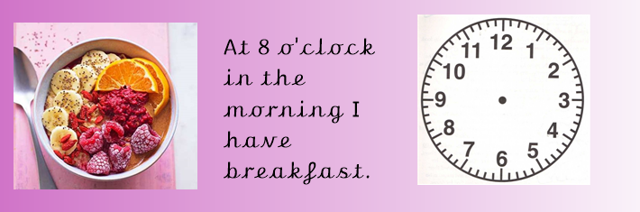
Enquiry  30 minutes. | Previously we have looked at materials. we found out materials that were waterproof, soft, hard, rough, bumpy and heavy. Today I would like you to think about different materials and whether they sink or float. We did a similar test when we worked out the best materials for our boats. You can use any objects around your house as the materials. You can use a paddling pool, sink, basin, bowl or bath to perform the test. Here is a sheet to help:  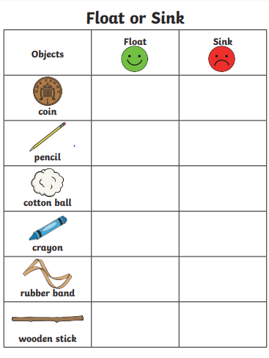  https://www.bbc.co.uk/bitesize/topics/zrssgk7/articles/z9pgcdm
Reading | Read an e-book on Bug Club and answer the comprehension questions.  