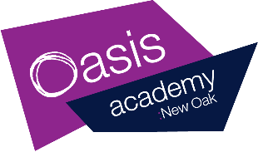
Year R Home Learning – Week commencing 27/04/20
Suggested daily timetable
9am – Wake up song
9:05 – 9:30 Phonics
9:30 – 10:00 Writing
10:30 – 11 – Snack and run around
11-11:30 – Maths
11:30 – 1 – Lunchtime
1:30 – 2 – Art/PSHE/PE/Topic
2-2:30 – Reading book
3:00 Free time
(Remember to help out your family with preparing lunch or dinner)
Here is your Home Learning Timetable for this week and an example of a daily timetable you may wish to follow but please feel you don’t have to.
This week’s theme and story is ‘Superworm’.
We would love to see photos and videos on Tapestry of what you are doing so please upload at least two observations a week of what you are doing at home.
We will also be uploading videos and stories so please keep checking on Tapestry for regular updates.

Thursday
Phonics  30 minutes  oa | Please go through the Phonics Sounds PowerPoint with your child before watching the daily Phonics video that will be uploaded to Tapestry.  Today’s video will include:  - Letter formation  - Writing words with ‘oa’  - Reading a sentence  Challenge: Write a silly sentences with ‘oa’ words.
Writing  30 minutes | Just like in Superworm we are looking for rhymes everywhere this week.  Today you are going to find rhyming pairs and write some of your own too.  Details are on the PowerPoint.  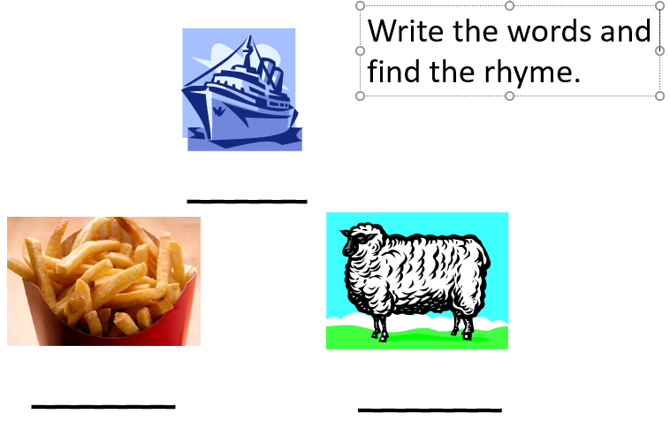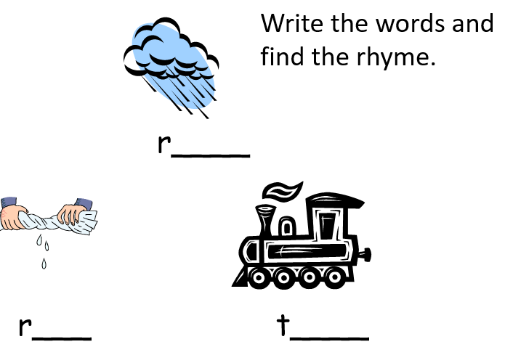
Maths  30 minutes | Today, you are going to explore the idea of more and less. In the powerpoint, you can find some apple cards and 2 ideas for games. Remember, if you don’t have a printer then you can just draw the apples on bits of paper.
Sing and Dance  30 minutes | https://www.youtube.com/watch?v=-eajwaH0_2c  Watch this video and make up a dance to go along with the song – we would love to see videos of this on Tapestry!
Reading | Read an e-book on Bug Club and answer the comprehension questions.

