Home Learning – Tuesday 28th April 2020

Reading  30 minutes | Reading extract and questions:  Year 4  Son of the Sea  For two long, silent hours, Duncan slouched beside his Dad as their battered old car bumped and bounced along the dark track. All the time, the wind howled like a hungry phantom as it hurled an endless supply of frozen rain at their windscreen.  Not exactly how Duncan had planned on spending his tenth birthday.  He had wanted to hang out with Callum, Rajesh and Skye, but no – Dad had said he had ‘something special planned’. This was weird, even for Dad. Not that Duncan didn’t love his father dearly, of course he did. Since his mum had left them when he was just a baby, the pair of them had stuck together. He still wished he was with his friends though.  “Maybe next year,” he muttered to himself as the car finally stopped.  “Stop your mumblin’ and get yourself out of the car son,” grunted Dad.  “Where are we?” asked the boy.  “I’ll tell ya when we’re out of the wind,” said Dad. “Now don’t forget your hat.”  Stepping out of the car was like disappearing into a pitch-black tornado. Like an iron fist, his father’s hand appeared from the gloom and guided him around the car. They kept pushing forwards against an invisible pressure like a night dragon’s breath but eventually Dad had guided Duncan to safety. They crouched out of the wicked wind’s reach.  “You’re ten now son,” Dad called into his ear. “In your culture, that means you’re an adult. So she wants to congratulate ya!”  “An adult?” spluttered Duncan. “My culture? Who’s she?”  “Hush now!” his father yelled excitedly, pointing. “Look – there she is!”  The full moon had painted everything in its silvery light so Duncan could see the beach quite clearly. There, on a rock just out to sea, sat a seal. A magnificent, glimmering seal but still just a seal.  “It’s a seal,” said Duncan, flatly.  “Go on, go on!” cried Dad. “Take your boots and socks off and paddle out to her!”  Duncan’s mouth opened and closed silently a few times before he managed to respond. “What?”  It was true that Duncan did love swimming. It was also true that he loved spending time in the sea so much that his Dad called him ‘The son of the sea.’ But paddling in a stormy sea in the middle of a February night? No way!  “Ya trust me, don’t ya son?” asked Dad, placing his big hands on his son’s shoulders. Duncan gulped then nodded. “Then go to her!”  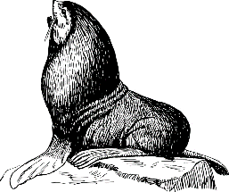  Duncan found himself doing as he was told. He was soon waddling like a penguin onto the freezing sand. The seal just stared at him. What was he doing? Somehow, he kept going.  Then, as soon as his numb toes touched the icy waters, the seal glowed silver, then white. It was a blinding, blazing white that was too bright to look at. Duncan stumbled backwards and collapsed onto the sand. When he looked up, all he could see was an empty seal skin lying on the rock in the water. Then he noticed the silent silver figure beside him. She laid a misty hand on his shoulder and smiled.  “Happy birthday, my son,” she whispered.  Questions for Son of the Sea  Inference  7. When Duncan got out of the car, why was it like disappearing into a pitch-black tornado?  _______________________________________________________________________________________  8. After Dad says ‘Then go to her’, how do we know that Duncan does as he is told without thinking?  _______________________________________________________________________________________  9. Then he noticed the silent silver figure beside him. Who is this figure? ____________________________  Explain how you know. ____________________________________________________________________  _______________________________________________________________________________________  Summarise  10. Using the whole text, tick one box in each row to show whether each statement is true or false.  True False  Duncan wanted to go on a long drive for his birthday.  It was a wet, stormy night.  Duncan usually loved spending time in the sea.  Predict  11. Predict why Duncan’s mother left him when he was a baby.  _______________________________________________________________________________________  _______________________________________________________________________________________  Compare  12. Read this passage:  “Hush now!” his father yelled excitedly, pointing. “Look – there she is!”  “It’s a seal,” said Duncan, flatly.  “Go on, go on!” cried Dad. “Take your boots and socks off and paddle out to her!”  Duncan’s mouth opened and closed silently a few times before he managed to respond. “What?”  Duncan and Dad react differently to seeing the seal.  How does Duncan react?  Tick one  He is more excited.  He is more scared.  He is happier.  He is less excited.
GPS warm-up  10 minutes | Y4 Grammar and Punctuation Quiz 2  1. Complete the sentences below by writing the conjunctions from the box in the correct places.  Use each conjunction only once.  but because and  He wore his coat _________________ it was raining.  Tom _________________ Amy walked to the shops.  She was allowed a scooter _________________ not a bike.  ______  1 mar  2. Which sentence uses a comma correctly?  Tick one  Yesterday he went, to see the new film.  Yesterday he went to see the new, film.  Yesterday he went to see the new film,  Yesterday, he went to see the new film.  ______  1 mark  3. Circle the most suitable pronoun to complete the sentence.  The girl went to a dance competition and __________ was happy with second place.  they she her them  ______  1 mark  4. Write the contracted form of the underlined words in the box.  The referee does not seem fair.  ______  1 mark  5. Circle all the adjectives in the passage below.  The enormous, gloomy castle towered over the  village. The birds glided eerily above the tall  turrets.  ______  1 mark  6. Which sentence uses book as a verb?  Tick one  I lost my library book.  This book is excellent.  I need to book my train ticket.  The book needs repairing.  ______  1 mark  7. Insert an apostrophe in the correct place in the sentence below.  M r G r e e n s n e w c l a s s a l l w o r e f u n n y  r e d h a t s.______  1 mark  8. Complete table below with the missing singular or plural spelling. One has been done for you.  Singular Plural  teacher teachers  school  tables  classes  child  Spellings to learn: 2 day activity  Antiseptic anticlockwise  antisocial antidote  antibiotic anti-venom  anti-aging antifreeze  antiperspirant antigravity  Learn the words and write one sentence using each of the words in it.
Writing  30 minutes | Today we will continue with instruction writing.  Think back to the game you played yesterday.  What order should the instructions be written in?  What might be your opening paragraph/sentence that introduces the instructions and the game? What might you say about it to encourage people to play the game?  Think about some of the Phrases that would be positive.  A game for all the family.  A game that requires more luck than judgement.  Can you beat the rest of your family in this fun-packed game?  You decide which is the most useful.  Don’t forget to list what you need, maybe using bullet points for each item. Write them as a vertical list rather than in a sentence separated by commas,  Next sub-heading introduces the section that explains how you play the game. Don’t forget to use sentence starters that show sequencing. Firstly, Next, After that, Finally.  Then end your instructions with a sentence encouraging the players to have fun.  Would be nice to finish your work with a picture. Maybe a picture of the board game and pieces or people sat playing it.  Good luck and enjoy it.
Arithmetic  10 minutes | Test questions 6 to 10  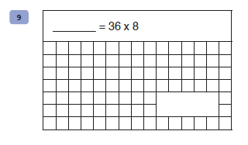  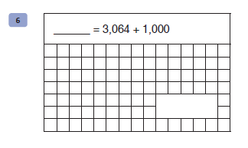  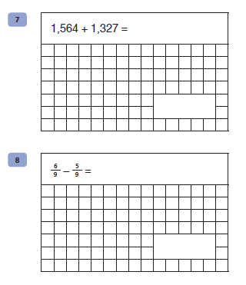  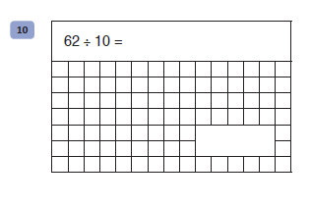
Maths  30 minutes | Draw hands on these clocks to show the time from the digital clock. These are different to yesterday because they show 24 hour times. Think carefully about what time it is.  Remember, shorter hand shows the hour and longer hand shows how many minutes past.  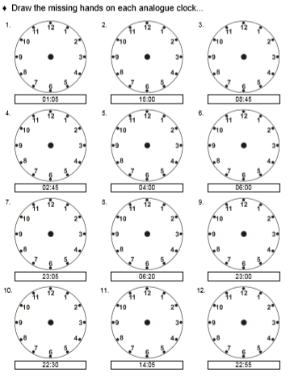
Enquiry/Project work  30 minutes | For this activity you need a blank piece of paper and a pencil. You can also use colouring pencils to colours your finished product.  Look through a newspaper or magazine to find a picture of a face. It is better to find one of a face that is looking directly at the camera, not a face turned to one side or the other. Please make sure it is a picture you are allowed to cut out of the paper or magazine. Please don’t hack into a sibling or parent’s magazine collection if they are being saved!.  Another way to get a picture could be to take a photograph and print it off. It would be fun to do this with a picture of yourself too, but only if you are allowed to print.  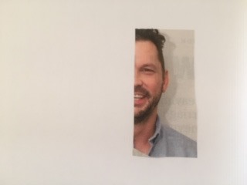  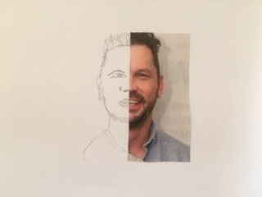  Cut the image in half straight down the middle and stick half of it to the piece of plain paper. Then you need to draw the other half of the face and shoulders just using what it on the page to guide you.  If you chose a famous person, eg actor, sport person, see if someone at home can recognise them from your drawing.  If you chose yourself, how much does it look like you?  I would love to see some of these so please feel free to email me a photo of your work. It might even end up on our school Facebook page. Or you might be awarded a certificate!!!
Answers for comprehension:
Inference
7. Pupils’ answers should reference that it was really dark and windy outside.
8. Because Duncan ‘found himself doing as he was told’ / he went to her.
9. His mother – pupils should make reference to the figure calling Duncan her son. Some may reference Dad’s comment about Duncan’s culture and someone wanting to congratulate him on turning ten.

Summarise
10. Using the whole text, tick one box in each row to show whether each statement is true or false.

 | True | False
Duncan wanted to go on a long drive for his birthday. |  | X
It was a wet, stormy night. | X
Duncan usually loved spending time in the sea. | X

Predict
11. Answers should link to the text, e.g. she belonged in the ocean / she was a water spirit / she needed her seal skin / she wanted to spend time in the sea / she missed the sea / she missed other seals / she couldn’t survive on dry land.

Compare
12. He is less excited.

Grammar Punctuation and Spelling:

Qu. | Quiz 2 Answers | Notes
1 | He wore his coat because it was raining.  Tom and Amy walked to the shops.  She was allowed a scooter or roller skates. | Answers must not include  capital letters.
2 | Yesterday, he went to see the new film. (Option 4)
3 | she
4 | doesn’t | Answers must be spelt correctly.  Apostrophes must be curved to  the left.
5 | enormous, gloomy, tall | Also accept answers that have  been underlined.
6 | I need to book my train ticket. (Option 3)
7 | M r G r e e n’ s n e w c l a s s a l l w o r e f u n n y  r e d h a t s. | Apostrophes must be curved  to the left.
8 | Singular Plural  teacher teachers  school schools  table tables  class classes  child children | Do not accept answers with  apostrophes. Answers must be  spelt correctly.

Arithmetic:
