Home Learning – Monday 27th April 2020

Reading  30 minutes | Reading extract and questions:  Year 4  Son of the Sea  For two long, silent hours, Duncan slouched beside his Dad as their battered old car bumped and bounced along the dark track. All the time, the wind howled like a hungry phantom as it hurled an endless supply of frozen rain at their windscreen.  Not exactly how Duncan had planned on spending his tenth birthday.  He had wanted to hang out with Callum, Rajesh and Skye, but no – Dad had said he had ‘something special planned’. This was weird, even for Dad. Not that Duncan didn’t love his father dearly, of course he did. Since his mum had left them when he was just a baby, the pair of them had stuck together. He still wished he was with his friends though.  “Maybe next year,” he muttered to himself as the car finally stopped.  “Stop your mumblin’ and get yourself out of the car son,” grunted Dad.  “Where are we?” asked the boy.  “I’ll tell ya when we’re out of the wind,” said Dad. “Now don’t forget your hat.”  Stepping out of the car was like disappearing into a pitch-black tornado. Like an iron fist, his father’s hand appeared from the gloom and guided him around the car. They kept pushing forwards against an invisible pressure like a night dragon’s breath but eventually Dad had guided Duncan to safety. They crouched out of the wicked wind’s reach.  “You’re ten now son,” Dad called into his ear. “In your culture, that means you’re an adult. So she wants to congratulate ya!”  “An adult?” spluttered Duncan. “My culture? Who’s she?”  “Hush now!” his father yelled excitedly, pointing. “Look – there she is!”  The full moon had painted everything in its silvery light so Duncan could see the beach quite clearly. There, on a rock just out to sea, sat a seal. A magnificent, glimmering seal but still just a seal.  “It’s a seal,” said Duncan, flatly.  “Go on, go on!” cried Dad. “Take your boots and socks off and paddle out to her!”  Duncan’s mouth opened and closed silently a few times before he managed to respond. “What?”  It was true that Duncan did love swimming. It was also true that he loved spending time in the sea so much that his Dad called him ‘The son of the sea.’ But paddling in a stormy sea in the middle of a February night? No way!  “Ya trust me, don’t ya son?” asked Dad, placing his big hands on his son’s shoulders. Duncan gulped then nodded. “Then go to her!”  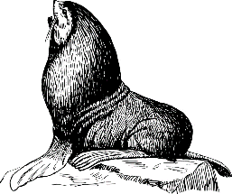  Duncan found himself doing as he was told. He was soon waddling like a penguin onto the freezing sand. The seal just stared at him. What was he doing? Somehow, he kept going.  Then, as soon as his numb toes touched the icy waters, the seal glowed silver, then white. It was a blinding, blazing white that was too bright to look at. Duncan stumbled backwards and collapsed onto the sand. When he looked up, all he could see was an empty seal skin lying on the rock in the water. Then he noticed the silent silver figure beside him. She laid a misty hand on his shoulder and smiled.  “Happy birthday, my son,” she whispered.  Questions for Son of the Sea  Vocabulary  1. Look at the first paragraph. Find and copy the word that means ghost.  ____________________  2. Which word below could have been used to describe Duncan’s car?  Tick one.  new shabby  smart crispy  3. He had wanted to hang out with Callum, Rajesh and Skye… What does the phrase ‘hang out with’ mean in this sentence?  _______________________________________________________________________________________  Retrieval  4. What did Duncan say when the car stopped?  _____________________________________________________________  5. What does Duncan’s dad ask him to remember?  ____________________  6. In which month was Duncan’s birthday?  ____________________
GPS warm-up  10 minutes | Y4 Grammar and Punctuation Quiz 1  1. Underline the conjunctions in the sentences below.  He brushed his teeth and then he went to bed.  She wanted to play outside but it was raining.  ______  1 mar  2. Write the comma in the correct place in the sentence below.  Quietly I crept into the haunted house.  ______  1 mark  3. Replace the underlined word with the correct pronoun.  Ben was hurt. Ben was crying.  ______  1 mark  4. Write one adverb to complete the sentence below.  ______________________, I went to the cinema.  ______  1 mark  5. Which sentence is an exclamation?  Tick one  What time did you wake up this morning  What a mean thing to say  Where will I find a new pencil  The people in this town are lovely  ______  1 mark  6. Tick one box in each row to show whether the underlined word is an adjective or an adverb.  Adjective Adverb  The empty house was haunted.  The boy looked carefully.  She would tidy her room next.  ______  1 mark  7. Insert an apostrophe in the correct place in the sentence below.  T h e b o y s w e n t t o l o o k a t K e v i n s n e w  h a m s t e r s.  ______  1 mar  8. Draw a line to match each word to the correct plural spelling.  Word Suffix  sandwiches  sandwich  sandwichs  drinkes  drink  drinks  Spellings to learn: 2 day activity  Antiseptic anticlockwise  antisocial antidote  antibiotic anti-venom  anti-aging antifreeze  antiperspirant antigravity  Learn the words and write one sentence using each of the words in it.
Writing  30 minutes | Over the next week you will be writing some instructions.  Find a game you enjoy playing and have a game of it. This will help you remember the rules and how to play it. It should also remind you of the order of play, what you need to play and how you can win.  Your task today is to play the game. Play it with a parent/carer or siblings. Discuss the order of play while playing it and make some notes if they will help you to explain the game in a set of instructions. It is a good idea to choose a game you know well, eg Snakes and Ladders, because the learning objective will be about writing a clear set of instructions using different features well.  So enjoy your research time today and remember, no cheating!!
Arithmetic  10 minutes | Test questions 1 to 5
Maths  30 minutes | 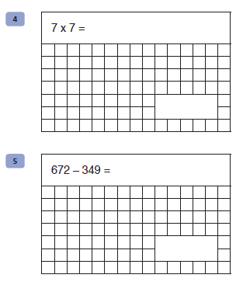  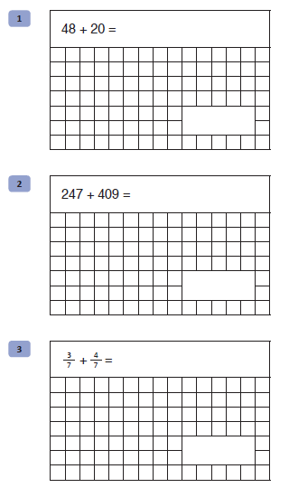  hands on these clocks to show the time from the digital clock.  Remember, shorter hand shows the hour and longer hand shows how many minutes past.  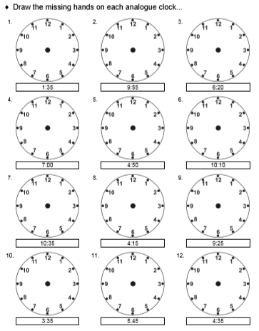
Enquiry/Project work  30 minutes | We studied sound and how we make sounds in term 3. We looked at how we can see the vibrations made eg banging a drum with rice on the drum skin. You also made musical instruments that could create high and low pitch sounds.  I would like you to create a poster demonstrating everything you learned about sound. It should include a diagram of the ear, with labels. It should also include pictures of instruments and a clear explanation on how to make it play a high note or a low note. To make it more interesting you can use images from magazines, old catalogues or newspapers, especially if you don’t want to draw complicated instruments.  Remember to make use of the knowledge organiser that was sent home with your original home learning pack. It will give you lots of useful information you can add.  Please feel free to photograph your work and send me the photos. I would love to see them.  Good luck
Answers for comprehension:
Vocabulary
1. phantom
2. shabby
3. spend time with / hang around with / relax with / be with / play with

Retrieval
4. “Where are we?”
5. his hat
6. February

Grammar Punctuation and Spelling:
Qu. | Quiz 1 Answers | Notes
1 | and, but | Also accept answers that have been circled.
2 | Quietly, I crept into the haunted house. | Commas must be the correct size and must be curved to the left.
3 | He | Answers must be spelt correctly.
4 | Any appropriate adverb.  E.g. Yesterday, Earlier, Excitedly | Answers must be spelt correctly and must start with a capital letter.
5 | What a mean thing to say (Option 2)
6 | Adjective Adverb  The empty house was haunted.  The boy looked carefully.  She would tidy her room next.
7 | T h e b o y s w e n t t o l o o k a t K e v i n’ s n e w  h a m s t e r s. | Apostrophes must be curved to the left.
8 | Word Suffix  sandwiches  sandwich  sandwichs  drinkes  drink  drinks

Arithmetic:
