Home Learning – Friday 1st May l 2020

Reading  30 minutes | Reading extract and questions:  Year 4  Son of the Sea  For two long, silent hours, Duncan slouched beside his Dad as their battered old car bumped and bounced along the dark track. All the time, the wind howled like a hungry phantom as it hurled an endless supply of frozen rain at their windscreen.  Not exactly how Duncan had planned on spending his tenth birthday.  He had wanted to hang out with Callum, Rajesh and Skye, but no – Dad had said he had ‘something special planned’. This was weird, even for Dad. Not that Duncan didn’t love his father dearly, of course he did. Since his mum had left them when he was just a baby, the pair of them had stuck together. He still wished he was with his friends though.  “Maybe next year,” he muttered to himself as the car finally stopped.  “Stop your mumblin’ and get yourself out of the car son,” grunted Dad.  “Where are we?” asked the boy.  “I’ll tell ya when we’re out of the wind,” said Dad. “Now don’t forget your hat.”  Stepping out of the car was like disappearing into a pitch-black tornado. Like an iron fist, his father’s hand appeared from the gloom and guided him around the car. They kept pushing forwards against an invisible pressure like a night dragon’s breath but eventually Dad had guided Duncan to safety. They crouched out of the wicked wind’s reach.  “You’re ten now son,” Dad called into his ear. “In your culture, that means you’re an adult. So she wants to congratulate ya!”  “An adult?” spluttered Duncan. “My culture? Who’s she?”  “Hush now!” his father yelled excitedly, pointing. “Look – there she is!”  The full moon had painted everything in its silvery light so Duncan could see the beach quite clearly. There, on a rock just out to sea, sat a seal. A magnificent, glimmering seal but still just a seal.  “It’s a seal,” said Duncan, flatly.  “Go on, go on!” cried Dad. “Take your boots and socks off and paddle out to her!”  Duncan’s mouth opened and closed silently a few times before he managed to respond. “What?”  It was true that Duncan did love swimming. It was also true that he loved spending time in the sea so much that his Dad called him ‘The son of the sea.’ But paddling in a stormy sea in the middle of a February night? No way!  “Ya trust me, don’t ya son?” asked Dad, placing his big hands on his son’s shoulders. Duncan gulped then nodded. “Then go to her!”  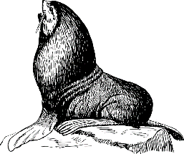  Duncan found himself doing as he was told. He was soon waddling like a penguin onto the freezing sand. The seal just stared at him. What was he doing? Somehow, he kept going.  Then, as soon as his numb toes touched the icy waters, the seal glowed silver, then white. It was a blinding, blazing white that was too bright to look at. Duncan stumbled backwards and collapsed onto the sand. When he looked up, all he could see was an empty seal skin lying on the rock in the water. Then he noticed the silent silver figure beside him. She laid a misty hand on his shoulder and smiled.  “Happy birthday, my son,” she whispered.  Son of the Sea  After answering many questions about the extract this week, today I would like you to write a summary of it. Remember that a summary is a shortened version of a story so it does not need to include every detail. Use the information in the text to help you decide what Is important to include. If you have time you can also draw an illustration to go with the extract.  Enjoy!
GPS warm-up  10 minutes | Y4 Grammar and Punctuation Quiz 5  1. Circle one word in each set of brackets to complete the sentences in the past tense.  He took off his coat before he ( sat / sits ) down.  Yesterday, I ( ride / rode ) my bike because it was a nice day.  ______  1 mark  2. Tick one box in each row to show the word class of the underlined word.  Sentence Noun Adverb Adjective  The boy ran fast.  I quickly completed my work.  The painting is beautiful.  We arrived late to the party.  ______  1 mark  3. Change the following statement to a question. Do not use any additional words. Remember to punctuate your sentence correctly.  Tim can run fast.  ____________________________________________  ______  1 mark  4. Match the suffixes to the root words to create three new words.  Root word Suffix  inform ation  complete ous  mountain ly  ______  1 mark  5. Write a sentence using the word stamp as a noun. Do not change the word in any way. Remember to punctuate your sentence correctly.  _____________________________________________  _____________________________________________  ______  1 mark  6. What is the name of the punctuation mark in the word couldn’t in the sentence below?  a) Sam and Cath couldn’t attend the school fair.  _____________________________  b) What is the function of the punctuation mark?  _____________________________________________  _____________________________________________  ______  1 mark  7. Tick the option which shows how the underlined words in the sentence below are used.  The beautiful, exotic butterfly landed on the delicate flower.  Tick one  as a fronted adverbial  as a subordinate clause  as a noun phrase  as a conjunction  ______  1 mark  8. Which sentence uses inverted commas correctly?  Tick one  “Stop the bus”, pleaded Sam.  “Stop the bus,” pleaded Sam.  “Stop the bus, pleaded” Sam.  ”Stop the bus, pleaded Sam.  Spellings to learn:  Today is test day. Please ask a grown up or older sibling to test you on any 10 of the 20 words you have been learning this week. Good luck. Think about the prefixes and root words and how they will help you spell the words.
Writing  30 minutes | Today we will continue with instruction writing.  It is writing day.  I would like you to write a very clear set of instructions on how to wash your hands effectively during this time.  You must include in introductory sentence, a list of what you will need from soap to hot water, a sequenced set of steps that lead towards properly washed hands.  I would like to see headings ads subheadings, bullet points, numbered steps, use of time words like first, next, after that and finally. Also, please include pictures, if not photos then drawn pictures to illustrate your point.  Have fun writing.  Think about presentation, handwriting, use of a ruler to underline.  Good luck.
Arithmetic  10 minutes | Arithmetic Test 3 questions 1 to 5  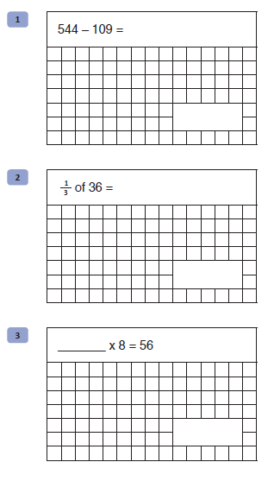  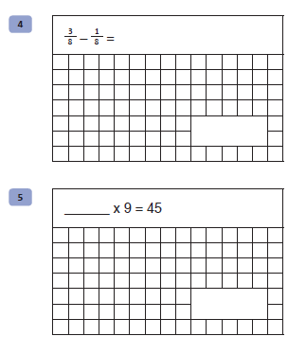
Maths  30 minutes | Maths Activity  Create a timetable of television programmes and activities you are going to watch and do over the weekend.  You must not watch more than 3 hours TV per day  You can include screen time eg ipad, laptop etc, as separate to TV screen time.  Don’t forget to list physical activity eg Joe Wicks activities separately too  Record how many minutes for each and then give a total for each section.  Don’t forget sleep time too.
Enquiry/Project work  30 minutes | Now it is your turn to be creative.  I would like you to draw a picture of a family member in the style of Picasso.  That way they cannot be offended by what you draw. You can just say “That’s how Picasso would have done it!!”  Again think about colours and look at some images on line to help with structuring the face, where the eyes are, shapes of nose etc.  Be as creative as possible and enjoy it.  Also, please send me some photos of your masterpieces. I think they would look great on Facebook New Oak group.
Grammar Punctuation and Spelling:
Qu. | Quiz 5 Answers | Notes
1 | sat, rode | Also accept answers that have been underlined.
2 | Sentence Noun Adverb Adjective  The boy ran fast.  I quickly completed my work.  The painting is beautiful.  We arrived late to the party.
3 | Can Tim run fast? | The sentence must be punctuated correctly.
4 | Root word Suffix  inform ation  complete ous  mountain ly
5 | Any sentence correctly using stamp as a noun.  E.g. Put the stamp on the letter.  Can I buy a stamp?  Do not accept sentences using stamp as a verb.  E.g. Stamp your foot. | The sentence must be punctuated correctly. Allow minor spelling errors that do not change the meaning of the sentence. Do not accept sentences where children have changed the word, e.g. stamps.
6 | a) apostrophe  b) Any answer referring to the appostrophe being used to indicate omission.  E.g.The apostrophe is for missing letters.  Couldn’t has the ‘o’ missing from could not.  There is a letter missing when you shorten could not to couldn’t. | Allow minor spelling errors that do not change the meaning.
7 | as a noun phrase (Option 3)
8 | “Stop the bus,” pleaded Sam. (Option 2)

Arithmetic:
