People I know at school

Higher Level Teaching Assistant

Mrs Evans

Class teacher

Mrs Webb

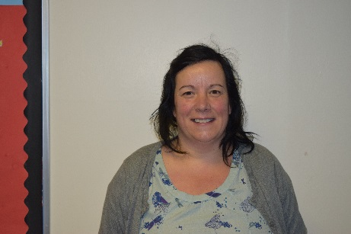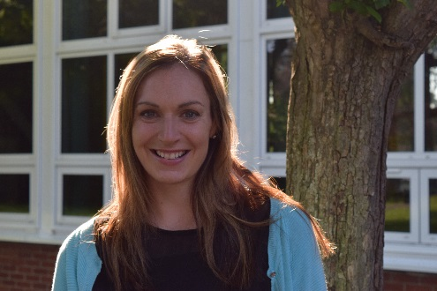

Head of School



Mrs Wilkins

Mrs Wilkins

This is me

I look like this… (can you draw a picture of yourself?)

This is my family (can you draw them?)

I like …… (what do you enjoy doing?)

My name is …… (can you write your own name?)

More about me (Parents and Carers can fill this bit out)

My favourite toy is… (can you draw it?)

These things worry me

I’m really good at (draw some of the things you are good at)

My favourite nursery rhyme or song is …