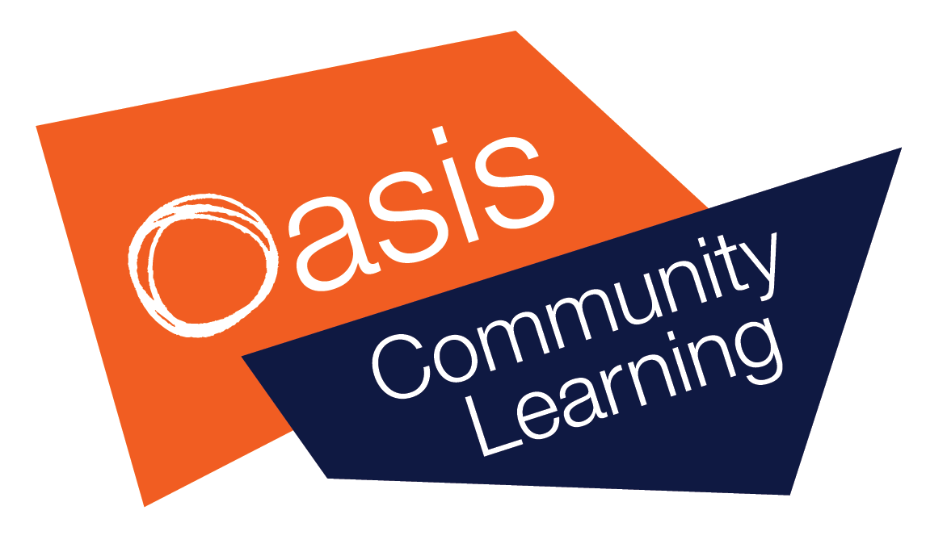

OCL Co-located Schools

Safeguarding Policy

March 2020 v2

Oasis Academy New Oak
Oasis Academy John Williams
Oasis Academy Brislington

Key Contacts for Safeguarding and Child Protection at the Academy

Principal: Oasis New Oak Muriel Wilkins
Contact email: Muriel.wilkins@oasisnewoak.org

Principal: Oasis John Williams Victoria Boomer-Clark
Contact email Victoria.boomer@oasisjohnwilliams.org

Principal: Oasis Brislington Peter Knight
Contact email: peter.knight@oasisbrislington.org

Designated safeguarding lead New Oak: Sinead Walsh
Contact email: Sinead.walsh@oasisnewoak.org
Telephone: 07971814276

Designated safeguarding lead John Williams: Andrea Rea
Contact email: andrea.rea@oasisjohnwilliams.org
Telephone: 07422073079
Designated safeguarding lead Brislington: Natasha Pugh
Contact email: Natasha.pugh@oasisbrislington.org
Telephone: 0797129587

Regional Director: Chris Chamberlain
Contact email: chris.chamberlain@oasisuk.org
Telephone: 07584521707

Oasis National Safeguarding Lead: Jon Needham
Contact email: jon.needham@oasisuk.org
Telephone: 07966 729 384

Local Authority Designated Officer (LADO): Nicola Laird
Contact email: nicola.laird@bristol.gov.uk
Telephone: 0117 9037795

Local Authority Social Work (MASH): Nicky Roberts
Contact email: nicky.roberts@bristol.gov.uk
Telephone:

Helpline numbers
NSPCC Adults Helpline 0808 800 5000 help@nspcc.org.uk
Refuge 24-hour National Domestic Abuse Helpline 0808 2000 247
NSPCC Childline 0800 1111 https://www.childline.org.uk/
Find your nearest foodbank https://www.trusselltrust.org/get-help/find-a-foodbank/

Contents:
- Policy purpose
- Procedures in respect of child concerns
  - Flow Chart for staff actions
- Children’s contact with the co-located setting
- On-line Safety
- Allegations against members of staff
- Appendices:
- Demographic Sheet for Safeguarding File
- Safeguarding File – chronology sheet
- Body Map Chronology Form
- Notice of Concern Form
- Home Visit Risk Assessment Form
- Letter of Authorisation
- RACI Matrix
- Change Control

Policy Purpose

1.1 The central purpose of Oasis remains the same: to transform communities so that they are safe and healthy places to be and to live. Even in this straightened times Oasis realises that it cannot make a commitment of this kind without first being committed to the safeguarding and safekeeping of its students.
1.2 Safeguarding and promoting the welfare of children remains everyone’s responsibility. Consequently, everyone who comes into contact with our children, whether it is those in our settings during this ‘time of closure’ or those students working from home, has a role to play in safeguarding and child protection. In doing so, all staff and volunteers should make sure their approach is child centred. This means that they should consider, at all times, what is in the best interests of the child.
1.3 It is important to remember whilst school provisions are consolidated onto one site staff should still follow the guidance of their local multi-agency safeguarding arrangements (MASA) and DSL’s should ensure that all staff are aware of those issues and systems for reporting and provide local safeguarding updates
1.4 This emergency policy has been developed to protect children, referencing key documents including:

- OCL Safeguarding & Child Protection Policy v6
- Keeping Children Safe in Education: Statutory Guidance for Schools and Colleges, updated September 2019, DfE
- Working Together to Safeguard Children, July 2018, HM Government
- Covid 19 – Safeguarding In Schools & Settings
  - https://www.gov.uk/government/publications/covid-19-safeguarding-in-schools-colleges-and-other-providers/coronavirus-covid-19-safeguarding-in-schools-colleges-and-other-providers
- Corona Virus – Covid 19, Guidance on Vulnerable Children and Young People
  - https://www.gov.uk/government/publications/coronavirus-covid-19-guidance-on-vulnerable-children-and-young-people/coronavirus-covid-19-guidance-on-vulnerable-children-and-young-people
- Covid 19 – Guidance for Schools about Temporary Closing
  - https://www.gov.uk/government/publications/covid-19-school-closures/guidance-for-schools-about-temporarily-closing
- Coronavirus (COVID-19): attendance recording for educational settings
  - https://www.gov.uk/government/publications/coronavirus-covid-19-attendance-recording-for-educational-settings
- Guidance on Social Isolation
  - This note is about managing social isolation
- OCL guidance on managing behaviour
  - Oasis guidance on behaviour, safety and formats for use/adapting in our new settings
1.5 In accordance relevant law and guidance this policy sets out our procedures for safeguarding and child protection during the Covid 19 emergency response. It applies to all staff working in this co-located setting regardless of their host school or employer.

Procedures in respect of Child Concerns:

2.1 Child abuse exists where children have been physically or emotionally abused or severely neglected. During the emergency Covid 19 measures the majority of our student population will not be seen by Academy staff, therefore it is essential that everyone is observant and listening to the voice of the child during any contact.
2.2 Despite the emergency nature of the current situation everyone in the co-located school has a role of recognising and responding to potential indicators of abuse and neglect, all action should be taken by those with statutory powers to help the child. Early contact and close liaison with such agencies are therefore regarded as essential by the academy.

2.3 For all children coming into the host school from a co-located school, with a known safeguarding or child protection need, a summary of needs and interventions MUST be provided by the ‘sending’ school DSL team. (see appendix 1)
2.4 In the event of an actual or suspected case of child abuse by adults, parents, or any other adult, it is the responsibility of staff to report this to the Designated Safeguarding Lead (DSL) as soon as possible. It is important that if staff overhear children discussing 'abuse' or 'neglect' that this information is relayed for investigation

2.5 The Designated Safeguarding Lead (DSL) is responsible for ensuring that children are identified, and the appropriate agency involved.

2.6 The Designated Safeguarding Lead (DSL) will attend any reviews called by the Local Authority by Skype or other means of social distancing and may call on appropriate members of staff for reports.

2.7 A confidential register will be maintained of all those students known to be at risk.

2.8 A ‘Bound Book’ will be initiated, and all concerns recorded in this document in chronological order. The Bound Book will have the following headings:
- Incident Reference Number
- Name of Child
- Date of Incident
- Time Concern was reported
2.9 A separate ‘Child Safeguarding’ file will be maintained for each child, all reports of concerns, details of contacts, referrals and actions will be recorded within this file.
- Where the Host School uses an electronic system such as CPOMS and the student is from the Host School – the student file will be maintained on the CPOMS system, but the notice of concern also recorded in the Bound Book
- Where the student is enrolled in another setting the safeguarding file will be held on paper and stored in a locked cabinet. Notice of Concerns will be recorded in the Host School’s bound book.
2.10 The Child Safeguarding File will consist of:
- The Demographic Details for the child – Appendix 1
- A File Chronology Form – Appendix 2
- A Body Map Chronology Form – Appendix 3
- Completed Notice of Concern Form – Appendix 4
- Referral documents
- Meeting Notes and correspondence

2.11 The Safeguarding file will return to the school of the pupil when normal education services are allowed, and this file will be uploaded to the safeguarding systems of that school.

  - The Bound Book will be retained and archived in the co-located school until 2045

- Flow chart for staff actions:

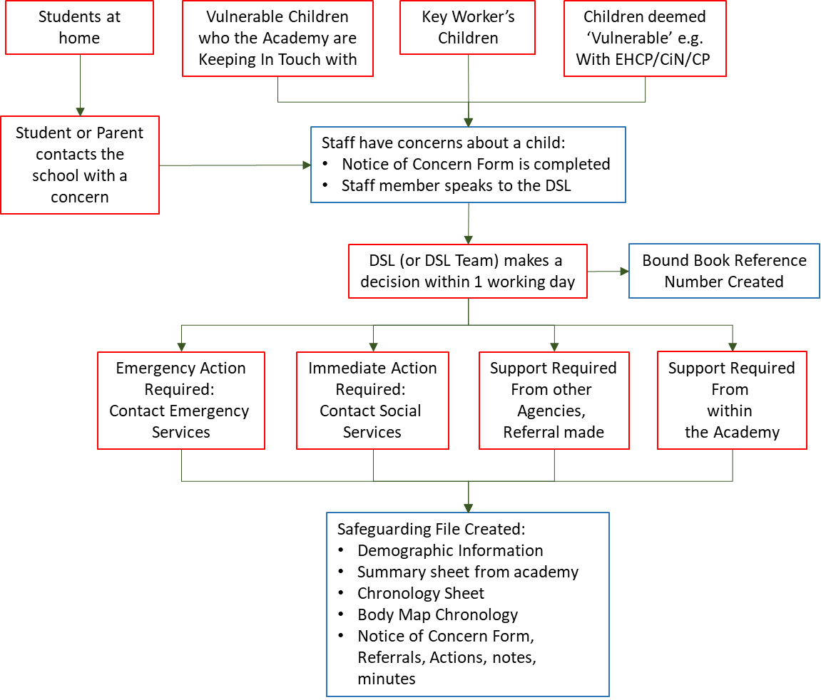
- Children’s contact with the co-located setting
4.1 Oasis academies believe all students, regardless of their circumstances or background are entitled to education which is suitable to their age, ability, aptitude and any special educational needs
However, the co-located school follows the Government advice that only if absolutely necessary will students attend the setting. These circumstances are:
- If the student is deemed vulnerable
- If the student has an EHCP
- If the student is in need of a social worker (on a CP or CiN Plan).
- If the student is the child of a Key Worker – where NO OTHER childcare facility can be arranged
4.2 For students coming into the setting the Government attendance sheet will be completed daily and sent to the DfE

4.3 For students assessed as vulnerable but are at home – these will fall into the following categories:

- Red – Students on a CP plan, CiN Plan, EHCP or where the DSL team assess critical risk – these students will be contacted daily
- Amber – Students on a CP plan, CiN Plan, EHCP or where the DSL team assess high risk – these students will be contacted every other day
- Blue – Students on a CP Plan, CiN Plan EHCP or EHCP where the DSL team assess medium risk – these students will be contacted every 3rd day
4.4 If families do not attend the co-located provision or do not answer their phones on the agreed contact date:

- Try all the available numbers for the family, including the emergency contact numbers.
- Following discussion between the DSL team:
· Re-assess the risk - does the lack of contact escalate your concerns?
· Seek advice from your local Social Care provision.
· For CP/CiN children speak to their allocated social worker or social work contact arrangements?
3. If required or it is requested by the Local Authority under their Delegated Powers you should undertake a Home Visit (see appendix 5 & 6). This visit will observe the protocols of Social Distancing and consist of a door step check only. Consideration should be given to the issue of Lone Working, and if possible the visit should be undertaken by 2 members of staff traveling separately. As well as assessing the status of the child and family, the importance of the KiT call should be reiterated
4. If the risk is deemed critical (i.e. risk to life) then the DSL speak to the Police and request a ‘safe & well’ check?

No student will be removed from an academy roll until all safeguarding checks have been completed or the whereabouts of a pupil/student have been established.

- Online Safety
5.1 It is essential that children are safeguarded from potentially harmful and inappropriate communications and online material. As such, the academy ensures appropriate procedures, filters and monitoring systems are in place in accordance with the following policies:
- Oasis E-Safety,
- Web Filtering and Device Monitoring.

5.2 Where students are using Oasis equipment at home, the ability of OCL to filter access is limited. Filtering will be provided to the extent that is possible within the technological constraints the current crisis allows.

5.3 Where OCL is providing Wi-Fi or internet access for young people at home, this service is unfiltered beyond its use with Oasis devices which have limited per device filtering as discussed in 5.2. Use of personal devices with these services will be unfiltered.

5.4 Students will be reminded of Internet Safety rules and parents will be expected to manage their children’s safety whilst at home.

5.5 Staff delivering teaching online should listen for any cues that indicate a safeguarding concern and report these to the DSL as soon as possible. These cues might include:
  - Comments or questions about child abuse or neglect
  - Inadequate supervision at home
  - The impact of food poverty
  - The health status in a family and any young caring responsibilities children have

Allegations against Members of Staff
6.1 All allegations of abuse made against a member of staff in relation to a student must be brought to the attention of the Principal immediately.
- For allegations about a member of staff – these should be reported to the Principal only.
- For allegations about the Principal/Executive Principal – these should be made to the Regional Director.
- For allegations about a Hub worker working for OCP – these should be made to the OCP National Director
- For allegations about a member of an OCL national team - these should be made to the Regional Director.
- For allegations about the Regional Director – these should be made to the Chief Executive’s Office.
6.2 If the allegation meets any of the following criteria, the Principal (or other lead person) must report it to the Local Authority Designated Officer the same day. If it is alleged that a teacher or member of staff (including a volunteer) has:

- Behaved in a way that has harmed a child, or may have harmed a child
- Possibly committed a criminal offence against or related to a child or
- Behaved towards a child or children in a way that indicates he/she is unsuitable to work with children

6.3 For other allegations the Principal and DSL will decide if further enquiries are required prior to referral to the Local Authority Designated Officer.

Where a member of our staff has been suspended, redeployed to work that is not regulated activity, dismissed or resigned from service. At the conclusion of any investigation enough evidence is gathered to have foundation then a referral will be made to the DBS Authority as soon as possible

6.4 The Local Authority's Designated Officer must be informed of all allegations that come to the Academy’s attention that meet the criteria so that he/she can consult police and social care colleagues as appropriate.

6.5 All alleged physical injuries must be investigated by the appropriate external agencies

Appendix 1- Demographic Sheet for Safeguarding File

Appendix 2 – Safeguarding File - Chronology Sheet

Appendix 3 – Body Map Chronology Form

Appendix 4 – Notice of Concern Form

Appendix 5 – Home Visit Risk Assessment Form

Appendix 6 – Letter of Authorisation

Appendix 7 – RACI Matrix

Policy Element | Leadership |  |  |  | Academy |  |  |  | Services |  | Team
A = Accountable  B = Responsible | OCL CEO | OCL COO | National Director | National Safeguarding Lead | Principal | Principal’s PA | Designated Safeguarding Lead | Deputy DSL | Whole School | IT services | Parents
Contact Details |  |  |  |  | A |  | R
Section 1 - Policy Purpose | A |  |  | R
Section 2 – Procedures in respect of Child Concerns |  |  |  |  | A |  | R
Section 3 – Flow chart for staff actions |  |  |  |  |  |  |  |  | A
Section 4 – Children’s contact with co-located setting |  |  |  |  |  |  | A | R
Section 5 – On-line Safety |  |  |  |  |  |  | A |  |  |  | R
Section 6 – Allegations against members of staff |  |  |  |  | A |  |  |  | R
Appendix 1 – Safeguarding File demographics |  |  |  |  |  |  | A | R
Appendix 2 – Safeguarding File chronology sheet |  |  |  |  |  |  | A | A
Appendix 3 – Body Map chronology form |  |  |  |  |  |  | A R
Appendix 4 – Notice of Concern form |  |  |  |  |  |  | A |  | R
Appendix 5 – RACI Matrix |  |  | A | R
Appendix 6 – Change Control |  |  | A | R

Appendix 8 – Change Control

1.0 | 03/03/20 | Jon Needham  National Safeguarding Lead | All Oasis Staff | Process update during Covid 19
2.0 | 27/03/20 | Jon Needham  National Safeguarding Lead | All Oasis Staff | Home visit advice

Approvals
This document requires the following approvals.
Name | Position | Date Approved | Version
CSG |  |  | 1.0

National/Local Policy

☐This policy must be localised by Academies

☒ This policy must not be changed, it is a National Policy (only change logo, contact details and yellow highlighted sections)

Position with the Unions

Does the policy require consultation with the National Unions under our recognition agreement?

☐ Yes ☒ No

Distribution
This document has been distributed to:
Name | Position | Date | Version
All Oasis Academy Principals, All Academies Staff and National Staff | - |  | 1.0

